Mapping and quantifying peatlands in Indonesia and Malaysia to achieve climate change and biodiversity goals

Matthew J. Ashfold¹, Helena Varkkey², Gusti Z. Anshari³, Sharon Seah⁴, Nurisa Wijayanti⁵, Fatima Tuzzahara Alkaf², Michelle L. E. Ang⁶, Zu Dienle Tan^{7,8}, Massimo Lupascu⁹, Nisa Novita¹⁰, Giles M. Foody¹¹, Hesti Lestari Tata¹², Dede Sulaeman¹³, Badrul Azhar¹⁴, Marshall Kana Samuel¹⁵, Sapta Ananda Proklamasi¹⁶, Agus Yasin¹⁷, Alex M. Lechner^{5,18}*

¹ School of Biological and Environmental Sciences, University of Nottingham Malaysia, 43500 Semenyih, Selangor, Malaysia
² Department of International and Strategic Studies, Universiti Malaya, 50603 Kuala Lumpur, Malaysia
³ Soil Science Department, Tanjungpura University, Pontianak, West Kalimantan 78124, Indonesia
⁴ ASEAN Studies Centre and Climate Change in Southeast Asia Programme, ISEAS – Yusof Ishak Institute, Singapore
⁵ Monash University Indonesia, BSD City, Banten 15345, Indonesia
⁶ Centre for Social Responsibility in Mining, Sustainable Minerals Institute, The University of Queensland, St Lucia Campus, Queensland 4072, Australia
⁷ Earth Observatory Singapore, Nanyang Technological University, Singapore
⁸ Asian School of the Environment, Nanyang Technological University, Singapore
⁹ Department of Geography, National University of Singapore, 1 Arts Link, Singapore 117570
¹⁰ Yayasan Konservasi Alam Nusantara, Graha Iskandarsyah Floor 3, Jalan Iskandarsyah Raya No. 66 C, Jakarta 12160, Indonesia
¹¹ School of Geography, University of Nottingham, Nottingham, NG7 2RD, UK
¹² Research Center for Ecology, National Research and Innovation Agency, Cibinong, 169111, Indonesia
¹³ Food, Land, and Water (FLW) Program, World Resources Institute (WRI) Indonesia, Jakarta, Indonesia
¹⁴ Department of Forest Science and Biodiversity, Faculty of Forestry and Environment, Universiti Putra Malaysia, 43400 Serdang, Selangor, Malaysia
¹⁵ Soil Science, Water and Fertiliser Research Centre, Malaysian Agricultural Research and Development Institute (MARDI), Serdang, Selangor, Malaysia
¹⁶ Forest Campaign, Greenpeace Southeast Asia, Jakarta, Indonesia
¹⁷ Ministry of Forestry, Jakarta, Indonesia
¹⁸ School of Resources and Civil Engineering, Northeastern University, Shenyang, China

*Corresponding author: Alex M. Lechner, alex.lechner@monash.edu, ORCID: 0000-0003-2050-9480

The main text is 7047 words, excluding Title page, Abstract(s), Tables, Figures, Captions, Required Statements (e.g. on Author Contributions), References and Supplementary Materials.

Abstract

Non-Technical Summary
Tropical peatlands in Indonesia and Malaysia store vast amounts of carbon and support rich biodiversity, and their degradation contributes to regional air pollution and global climate change. Policymakers and businesses rely on maps and datasets to manage peatlands, yet these data often contain major uncertainties. This review examines where these uncertainties arise, why they matter for policy and sustainability goals, and how they can be addressed. By improving mapping practices, collaboration across borders, and the way uncertainty is used in decision-making, peatland governance can become more effective and support long-term environmental and societal benefits.

Technical Summary
Tropical peatlands are globally critical ecosystems, storing carbon, sustaining unique biodiversity, and providing essential ecosystem services. In Indonesia and Malaysia, however, these landscapes are major sources of transboundary air pollution and greenhouse gas emissions, driven by drainage, deforestation and fire. Despite their importance for international climate and biodiversity agendas, effective management of Southeast Asian peatlands is constrained by persistent challenges in accurately mapping and quantifying peatland extent, ecological condition, and impacts of anthropogenic activities. Crucially, we argue that peatland data uncertainty is not only a technical mapping problem, but a governance problem, because it propagates directly into decisions on compliance, carbon accounting, restoration prioritization, and biodiversity protection, ultimately influencing policy effectiveness. Drawing on a structured literature synthesis, insights from a hybrid expert workshop, and comparative analyses of open-access datasets, this review systematically evaluates current knowledge on the sources and characteristics of uncertainty in peatland data. The review identifies seven key challenges for peatland data of relevance to climate and biodiversity governance systems. Building on the identified data challenges, we highlight three cross-cutting opportunities to strengthen peatland data and governance: (1) enhancing data practices across scales and borders, (2) constructively engaging with data uncertainty, and (3) valuing broader sustainability benefits.

Social Media Summary
Better peatland maps mean better climate and biodiversity policy. Our review identifies data challenges and policy opportunities.

1. Introduction

Peatlands are among Earth’s most carbon-rich and ecologically significant ecosystems. Despite covering only 3-4% of the land surface (~500 Mha), these ecosystems are estimated to store up to one third of the planet's soil carbon, double that held by the world's forests (UNEP, 2022). Peatlands in Southeast Asia, found primarily in Indonesia and Malaysia, are of global relevance. They account for around half of tropical peatland area, and are notable for vast carbon stocks, high endemism, and ecosystem services such as water filtration, flood mitigation, and forest products (Mishra et al., 2021). Indonesia and Malaysia, however, have been ranked first and fourth globally in peatland-related greenhouse gas (GHG) emissions (UNEP, 2022), driven by drainage, deforestation, and fire (e.g. Sasmito et al., 2025), often linked to global commodities such as oil palm and pulp, and to food production (e.g. Cao et al., 2026). Further impacts of anthropogenic activities in peatlands include “haze” air pollution, biodiversity loss, and land subsidence that collectively threaten livelihoods and health from regional to local community scales (Varkkey et al. 2024).

Ecosystem management and governance is challenged by difficulties in mapping and quantification (Castle et al., 2026). Indicators such as peatland extent, condition, and impacts of anthropogenic activities increasingly underpin sustainability governance approaches, including global trade and market mechanisms, certifications, and reporting frameworks. The European Union (EU) Deforestation Regulation requires companies selling commodities such as palm oil in the EU to demonstrate these products are deforestation-free through plot-based spatial data (European Parliament, 2023). Similarly, the Roundtable on Sustainable Palm Oil (RSPO) certification mandates companies use spatial data, including to confirm plantations have not been established on peatlands (RSPO, 2019). More broadly, corporate sustainability reporting frameworks may require companies to quantify and disclose activities and risks related to peatland emissions and impacts (Climate Catalyst 2023; Padfield et al 2016). The integrity of carbon credit projects operating under voluntary Monitoring, Reporting, and Verification (MRV) frameworks and emerging compliance markets also depends on accurate baseline mapping (Teo et al., 2023), including properties such as peatland extent, depth, carbon stocks, and historical disturbance. Regions of Indonesia and Malaysia, including peatlands, have globally significant potential for such projects (Soto-Navarro et al., 2020). Discrepancies between datasets can lead to varying quantifications, conflicting assessments of compliance, undermine the credibility of market mechanisms, and generate disputes over land-use rights, impacts and responsibilities (e.g. over fires causing “haze”; Lee et al., 2016). For Indonesia and Malaysia, where peatlands contribute substantially to national GHG emissions, uncertainties can affect evaluation of climate commitments and mitigation efforts (Goldstein, 2022; Varkkey et al. 2024). To illustrate the apparent magnitude of peatland emissions in Indonesia and Malaysia, the UNEP (2022) estimates are equivalent to 90% and 35%, respectively, of latest nationally reported energy sector emissions. As an illustration of uncertainty, these UNEP (2022) estimates are 39% and 67% higher, respectively, than comparable nationally reported peatland emissions (discussed in more detail in Sections 2.3, 3.3).

Difficulties in mapping and quantifying peatlands arise from several issues, including (1) inconsistent definitions of peat and peatland states, such as differences in peat depth and organic matter content thresholds; (2) divergent methodological approaches to quantification, such as whether peatland extent is estimated from field-based soil maps or remote sensing products; (3) uncertainties introduced when scaling sparse field observations to regional and national levels, and (4) through lack of transparent methodological assumptions and documentation. Such issues lead to differing estimates of peatland extent: as one example (discussed in more detail in Sections 2.1, 3.1), estimates of peatland extent for Indonesia and Malaysia in one spatially explicit dataset (Gumbricht et al., 2017) are 51% and 33% larger, respectively, than in another such dataset (Xu et al., 2018). Collectively, these issues manifest as spatial data uncertainty, reflecting the inherent imprecision, ambiguity, and error in representing geographic phenomena due to limitations in measurement, classification, and spatial and temporal resolution (Fisher, Comber, & Wadsworth 2006; Devillers & Jeansoulin 2006). Errors and uncertainties propagate through analytical workflows as datasets are combined, transformed, or aggregated, a process commonly referred to as error propagation (Heuvelink et al., 1989), which can magnify uncertainty in derived products such as estimates of oil palm plantation area on peatland. Spatial data quality, by contrast, refers to a dataset’s fitness for its intended use, commonly evaluated through accuracy, completeness, consistency, and currency (Goodchild 2008, Devillers & Jeansoulin 2006). Improving data quality can reduce uncertainty, but some degree of uncertainty inevitably persists (Lechner et al. 2012).

This paper aims to review the challenges of mapping and quantifying peatland extent and drivers and impacts of change, and to conduct a structured exploration of the dimensions and implications of peatland data uncertainty. Our central contribution is to show how uncertainty in peatland data propagates through analytical and governance workflows, from peatland extent mapping to land-use overlays, GHG emissions estimates, and sustainability interventions. Rather than treating uncertainty as purely a technical issue, we examine it as a primary constraint on evidence-based peatland governance. While we focus on peatlands in Indonesia and Malaysia, the concepts reviewed are more widely relevant to ecosystem management and governance. The review was conducted by peatland experts from environmental and academic organisations and from government bodies, through a hybrid workshop format, followed by written reflections and comparative spatial data analyses. Accordingly, this paper should be read as a structured, expert-informed synthesis supported by illustrative geospatial analyses, rather than as a systematic review or a definitive remapping of peatland extent. Methodological details are provided in the Supplementary Materials. We begin the review by outlining key characteristics of peatlands in both Indonesia and Malaysia, including current estimates of their extent, major anthropogenic impacts such as forest loss and drainage, and their role in national GHG emissions. We then present a structured examination of sources of uncertainty in peatland datasets, supported by illustrative, quantitative examples of peatland distribution and anthropogenic impacts, and highlight how data discrepancies influence estimates of GHG emissions. Finally, we discuss seven critical peatland data challenges, their associated data needs, uncertainties, and policy implications, and offer recommendations for strengthening peatland data and governance for sustainability. These recommendations are framed within three cross-cutting opportunities: (1) enhancing data practices across scales and borders, (2) constructively engaging with data uncertainty, and (3) valuing broader sustainability benefits.

2. The importance of peatland characteristics in Indonesia and Malaysia

Our workshop discussions were structured around four pre-determined themes: (1) Peatland data needs, (2) Mapping peatland and its condition, (3) Calculating GHG emissions from peatlands and (4) Cross-cutting challenges and opportunities for enhancing peatland data to support sustainability interventions (Table 1).

Table 1: Thematic areas and guiding questions used in the expert workshop, covering areas data are required for the sustainable management of, and policymaking for, peatlands in Indonesia and Malaysia. Questions were framed at a high level to accommodate a broad range of responses and open discussion.
Theme | Questions
Peatland data needs | Q1 What are the key policy areas which need robust data? And why?  Q2 What kinds of data are needed to manage peatlands sustainably? And why?
Mapping peatland extent, and its condition, and characteristics | Q1 How good are peatland datasets and which are missing or restricted or low quality? (e.g. peatland extent and physical state, biodiversity, haze)?  Q2 What are the main sources of peatland dataset uncertainty?  Q3 How do the above issues impact policy decisions?
Calculating GHG emissions from peatlands | Q1 What methodologies are used for calculating peatland GHG emissions?  Q2 How good are the carbon stock and GHG emission datasets, and which are missing or restricted or low quality?  Q3 What are the main sources of GHG emission estimation uncertainty?  Q4 How do the above issues impact policy decisions?
Cross-cutting challenges and opportunities for enhancing peatland data to support sustainability intervention efforts | Q1 How important is data transparency to support sustainability intervention efforts?  Q2 What is the role of stakeholders, particularly communities, in enhancing peatland data to support sustainability intervention efforts?  Q3 What are the scale and jurisdictional issues in enhancing peatland data to support sustainability intervention efforts?  Q4 What are the opportunities for harnessing the connections between datasets on GHG emissions and other sustainability dimensions (e.g biodiversity conservation, haze reduction) to support sustainable peatland interventions?

We integrated the expert inputs with literature information (e.g. Reed et al., 2022) to create Figure 1, which outlines key characteristics of peatland socio-ecological systems, including biophysical functions, anthropogenic activities, impacts and management approaches, alongside the range of governance factors relevant to peatland management and interventions. Through questions in our workshop, we also obtained views on key challenges, especially regarding peatland data, which we explore throughout this paper. In the following sections we present illustrative discussions and analyses regarding the key challenges of peatland extent, land use (especially oil palm) and GHG emissions. These illustrations help to support our broader discussion in the concluding section, where we return to the full list of challenges, and offer recommendations for strengthening peatland data and sustainable peatland governance.

Updated version (being finalised)
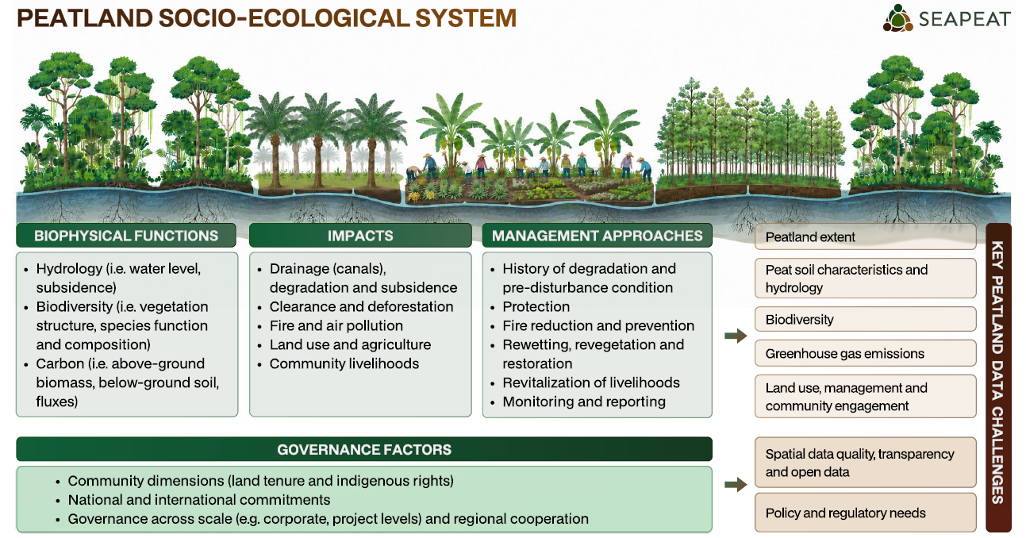

Earlier version (for reference)
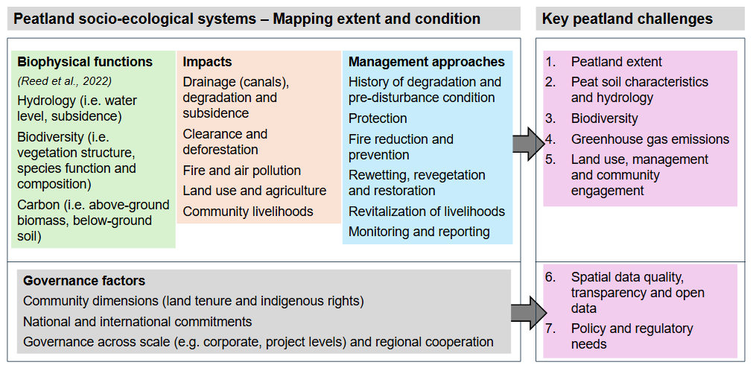
Figure 1: Key components of peatland socio-ecological systems in Indonesia and Malaysia, highlighting biophysical functions (after Reed et al., 2022), major social and environmental impacts, and management strategies and governance factors relevant to peatland sustainability. The diagram also identifies priority challenges requiring focused research and policy attention, including critical data needs for monitoring, modelling, and decision-making. These topics were derived from expert workshop inputs. Quantitative information, alongside illustrative discussion and analysis, is provided for the key challenges of peatland extent (Sections 2.1, 3.1), land use (especially oil palm; Sections 2.2, 3.2) and GHG emissions (Sections 2.3, 3.3).

2.1 Peatland extent
Understanding the extent, depth, and distribution of peatlands underpins their management and sustainability, informing further assessment of impacts, including biodiversity and GHG emission outcomes. Estimates of the total area of peatland in Indonesia and Malaysia range between 13.4–22.5 Mha and 1.4–3.0 Mha, respectively (Table 2). These estimates are derived from both global or pantropical (Xu et al., 2018; Gumbricht et al., 2017; UNEP, 2022) and national or regional (Wahyunto et al., 2003; 2004; 2006; Melling, 2016; Page et al., 2011a; Anda et al., 2021) assessments, which deploy varying methods and assumptions (e.g. in peat definition). Although estimates for each country differ by up to a factor of ~2, the extent of peatlands is clearly substantial. UNEP (2022) estimates that the two countries combined contribute 5% of the global peatland extent and in both countries, peatlands make up a similar and substantial fraction of total national area, with estimates ranging between 7–12% of national area in Indonesia (190.5 Mha) and 4–9% in Malaysia (33.1 Mha). While our focus throughout will be on the causes, implications, and need for greater consideration of data uncertainties, in Section 4 we will also discuss the feasibility of reductions in uncertainty.

Table 2: Comparisons of peatland area estimates, definition for peat used, associated spatial data, extent/resolution, availability of peatland data, and methodology for generating peatland maps for Indonesia and Malaysia.

Source | Peatland Area (Mha) |  | Peat definition | Spatial data? | Extent / Resolution | Availability | Methodology
Source | Malaysia | Indonesia
Page et al (2011a) | 2.59 | 20.69 | Soil layer with organic content of at least 65% and in minimum thickness of 30 cm. | No | Pantropical | Tabular in source | Compilation of global and tropical peatland inventories, reports and literature values, and national soil inventories.
Gumbricht et al (2017) | 2.96 | 22.54 | Soil at least 30 cm deep with at least 50% of organic content. Maximum peat thickness of 10 m. | Yes | Tropical and subtropical /  232 meter | Publicly available to download | Identification of peatland based on key indices needed for wetland development using models, satellite data (MODIS), and other spatial products.
Xu et al (2018) | 2.23 | 14.90 | The definition is based on the source of data used (can vary by country). | Yes | Global /  1:50,000 (Malaysia)  1:250,000 (Indonesia) | Publicly available to download | Meta-analysis of national and regional peatland maps
UNEP (2022) | 2.56 | 20.90 | Ecosystems with a peat soil of any thickness; generally minimum peat depth threshold of 30-40 cm used to define peat soil. | Yes | Global /  1 km | Publicly available to download | Compilation of literature, reports, and various national and global peatland/ peatland proxy data products, supplemented by peatland probability mapping, manual digitization, and satellite image classification.
Melton (2022) | 1.39 | 18.80 | Soil with a minimum of 30% dead organic matter by dry mass and a minimum peat thickness of 30 cm. | Yes | Global /  5 arc min | Publicly available to download | Machine learning trained on regional peatland and non-peatland maps and peatland predictors (biophysical, topographical, and meteorological data)
Wahyunto et al., (2002 - 2006) | - | 20.80 | Minimum thickness of 30 cm to delineate peatland | Yes | National (Indonesia) /  1:250,000 | Available upon request | Compilation of national maps and reports, satellite data (Landsat), and field survey data.
Anda et al (2021) | - | 13.40 | Histosol layer with minimum thickness of 50cm. | Yes | National (Indonesia) /  1:50,000 | Available for purchase or upon request | Compilation of national soil maps and peatland maps, field surveys and laboratory analyses, satellite data analyses (Landsat, SPOT) and other spatial products.
Melling (2016) | 2.60 | - | Classification includes "Peaty phase" for soil with a depth of less than 50 cm, and it must contain 65% organic matter. | No | National (Malaysia) | Tabular in source | Field surveys, and based on mapping by the Department of Agriculture, Malaysia (2002), Mutalib et al., (1991) and Department of Irrigation and Drainage, Sarawak (2014).

In Indonesia, the product of Anda et al. (2021) is the recognised official peatland map. Notably, this dataset contains the lowest estimate of Indonesia’s peatland area (13.4 Mha), likely due to the exclusion of peatlands with depths of less than 50 cm. Xu et al. (2018) provide a fairly similar estimate of 14.9 Mha, as they reference a previous official peatland map produced by the Ministry of Agriculture (Ritung et al., 2011). However, earlier national-scale maps (Wahyunto et al., 2003; 2004; 2006) estimated a substantially larger area of around 20.8 Mha, aligning more closely with some estimates in pantropical and global datasets (Table 2). For Malaysia, Melling (2016) reported a national peatland extent of 2.6 Mha. Other estimates of Malaysia’s peatland extent are reasonably consistent among global and regional assessments, ranging from 2.23–2.96 Mha, with the exception of the lower (1.39 Mha) estimate of Melton et al. (2022) (Table 2).

Given the substantial differences in total peatland area estimates, it is important to examine areas of discrepancies and alignments. We conducted analyses to compare the spatially explicit, publicly available, and commonly used peatland datasets of Gumbricht et al (2017) and Xu et al. (2018). While these are both global datasets, we focus our analyses on Indonesia and Malaysia. There are fundamental differences in the split of peatland areas among key regions of both countries (Table S1), with Sumatra making the largest contribution to Indonesia’s peatland area in the Xu et al. (2018) dataset, and Papua the largest contribution in the Gumbricht et al (2017) dataset. We also calculated the intersection between the spatial datasets (i.e. is peatland at the same location in both datasets?). Overall areas of agreement (Table S1) are low: in Indonesia, the area in which the two datasets agree is just 6.80 Mha. In Malaysia this area of agreement is 0.83 Mha. To facilitate spatial analyses of impacts in peatlands presented in Section 2.2, we created a combined peatland layer by merging the two datasets (details in Supplementary Materials). The combined peatland extent in this layer is 29.48 Mha in Indonesia and 4.34 Mha in Malaysia (Table S1). Importantly, this combined layer is likely to overestimate actual peatland area, and thus it is used as an illustrative envelope for downstream overlay analyses, rather than a preferred estimate of true peatland extent. Nevertheless, the area of agreement between the datasets in Indonesia (6.80 Mha) only covers 23% of the combined peatland extent. The equivalent area of agreement in Malaysia is 19%. Among sub-national regions, the largest agreement in Indonesia is in Sumatra (26%) and in Malaysia is in East Malaysia (20%) (Table S1). The causes and implications of these substantial uncertainties in peatland location are discussed further in Section 3.1, but they likely reflect variation in peat definitions, depth thresholds, mapping methods, and source data. This is important because uncertainty in peatland extent and location propagates directly into all subsequent overlays and assessments of impacts, emissions, and protection status.

2.2 Peatland impacts
Understanding the impacts of anthropogenic activities in peatlands is crucial for assessing the state of biophysical functions and for considering potential management approaches and interventions (Figure 1). As illustrations of the range of relevant activities and impacts, and to support later discussion on data uncertainties, we overlaid key activity and impact datasets (Table S2) on the combined peatland layer introduced in Section 2.1 (Figure 2). The significance of peatland extent uncertainty becomes clearer at this stage, because every downstream estimate of forest loss, drainage, oil palm extent, emissions, or protection in peatlands depends directly on the peatland map selected. Thus, while in principle these types of open-source spatial dataset can contribute to peatland monitoring and management systems across scales, poor practices and inconsistencies in mapping of peatlands can undermine such approaches.

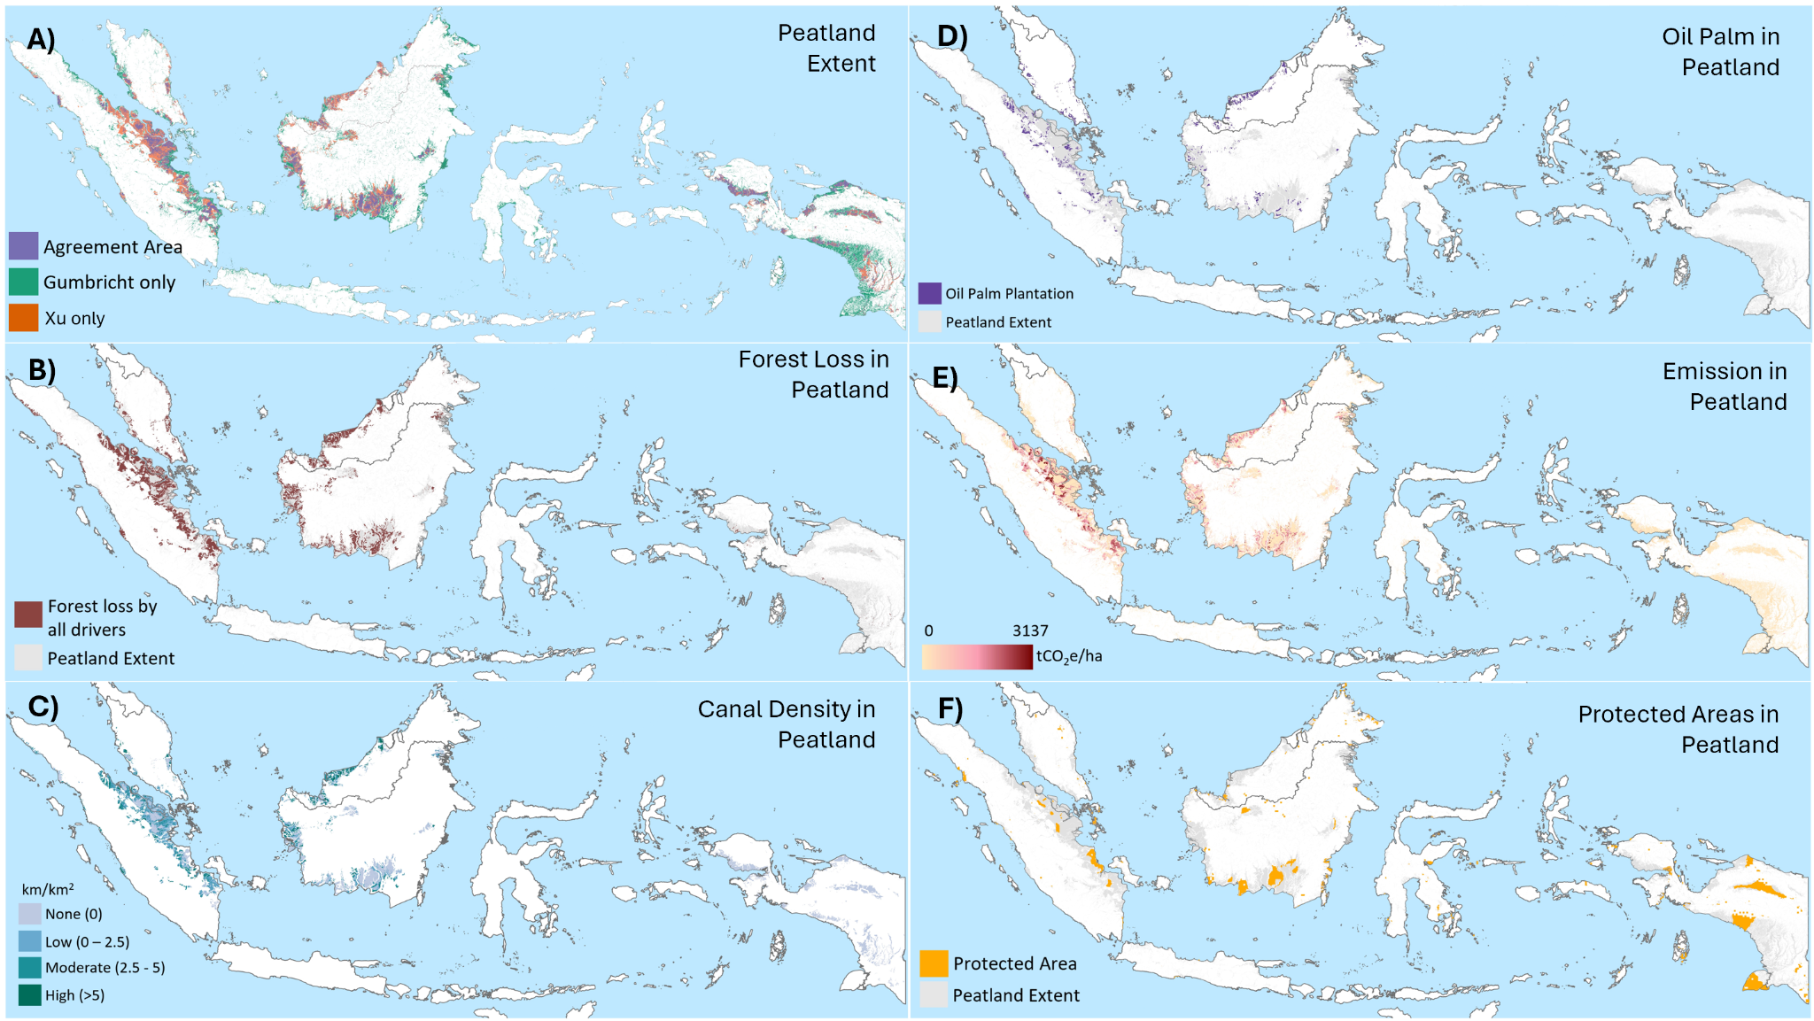Figure 2: Mapping of peatlands in Indonesia and Malaysia (A) using the Gumbricht et al. (2017) and Xu et al. (2018) datasets, with areas of agreement between datasets indicated. Peatland extent (B-F) is based on a combined layer created by merging the two datasets. Mapping of impacts within this peatland layer includes forest loss (B), canal density (C), oil palm (D), GHG emissions (E) and protected areas (F). Illustrative quantifications of peatland extent and impacts presented are in Table S1. Descriptions of the illustrative activity and impact datasets are in Table S2. The Figure is updated from Varkkey et al. (2024).

Substantial areas of peat swamp forest in Indonesia and Malaysia have been lost due to anthropogenic activities and land use/cover changes (e.g. Miettinen et al. 2016). Figure 2B illustrates forest loss within the peatland extent layer in Indonesia and Malaysia from 2001 to 2022, with loss reaching 6.9 Mha and 1.6 Mha, or 24% and 37% of the national peatland areas, respectively (Table S1). Sub-national regions with the largest fractional forest losses in peatlands are Sumatra (43%) and East Malaysia (39%) (Table S1).

There is close spatial correspondence between forest loss and the presence of canals that have been introduced to drain peat soils and to enable agriculture and logging (Figure 2C). Impacts on peatland biophysical functions are profound, through the lowering of water tables, leading to subsidence, carbon loss and vulnerability to fire (Hoyt et al., 2020). Fires within Southeast Asia’s peatlands have various impacts, including as sources of regional, trans-boundary air pollution or “haze” (e.g. Gaveau et al., 2014). Within our illustrative analyses, a substantial 1.40 Mha (i.e. 23%) of overall peatland forest loss (Figure 2B) in Indonesia was due to fires, whereas in Malaysia fire-related losses were just 0.07 Mha (4%) (Table S1). Regionally, the largest fraction of fire-related loss was found in Kalimantan (31%) (Table S1). These calculations are consistent with literature emphasising the association of forest loss, drainage and peatland fires in Indonesia (e.g. Adrianto et al., 2019; Lestari et al., 2024), and indicate a less prominent association between fire and peatland forest loss in Malaysia.

One common land use in deforested and drained peatlands is plantation agriculture, particularly oil palm (Miettinen et al., 2016). Our illustrative analysis suggests oil palm on peatland covers 2.2 Mha in Indonesia (8% of the peatland layer in Indonesia, Figure 2D), of which 1.5 Mha is “industrial plantation” (Table S1). Sumatra, with a total of 1.60 Mha, is the largest contributing region for Indonesia. In Malaysia, our analysis indicates oil palm covers 0.94 Mha (22% of the peatland layer in Malaysia), of which the majority, 0.82 Mha, is industrial plantation (Table S1). East Malaysia, with a total area of 0.63 Mha, is the major contributing region for Malaysia. For comparison, Miettinen et al. (2016) reported areas of oil palm in peat of 1.3 Mha in Sumatra (0.3 Mha smaller than our illustrative calculation) and 0.78 Mha in East Malaysia (0.15 Mha larger). We present a more detailed analysis of such uncertainties in areas of a major commodity crop in peatland in both countries in Section 3.2.

The loss of forest, drainage and conversion to plantation agriculture in peatlands are strongly associated with disturbance of soil carbon, and thus with GHG emissions. As one illustration, utilising one of the few spatially explicit forest-related GHG emissions datasets (Harris et al., 2021), on average between 2001-2022 annual emissions of 322 and 57 MtCO₂e occurred, respectively, in Indonesia and Malaysia within our peatland layer (Figure 2E). This represents 34% and 24%, respectively, of emissions from all forest types in the two counties in this dataset (Table S1). The substantial contribution of peatlands to GHG emissions in both countries is discussed in Section 2.3, and causes of variation between peatland emission estimates in Section 3.3.

As well as affecting biophysical functions of water and carbon, the various impacts on peatlands also threaten their unique biodiversity (Yule, 2010; Azhar et al., 2011; Sasidhran et al., 2016; Shuhada et al., 2017; Grover et al. 2024; Struebig et al., 2025). Peatlands of Indonesia and Malaysia host a range of plants, animals, and microbes, serving as sanctuaries for threatened species such as orangutans (Yule, 2010). Alongside restoration, protection is one key strategy to conserve peatland areas, their biodiversity, and their wider biophysical functions and ecosystem services (Novita et al, 2022). Depending on the legal category and national context, protected status may limit land clearance, drainage and canal construction, plantation expansion, peat extraction, deliberate burning and infrastructure development. Figure 2F suggests 3.6 Mha (or 13%) of our peatland layer for Indonesia is protected, whereas only 0.22 Mha (5%) in Malaysia is protected (Table S1). While just one illustrative analysis, the modest fractions of protected peatland in both countries indicate great potential to enhance interventions to support peatland sustainability.

2.3 Peatland greenhouse gas emissions
Multiple studies have emphasised the important contributions of peatlands to GHG emissions globally, and in both Indonesia and Malaysia (e.g. Miettinen et al., 2016; UNEP, 2022; Sasmito et al., 2025). As noted in the Introduction, UNEP (2022) ranked these two countries as first and fourth largest contributors to global emissions from peat decomposition, with estimated annual emissions of 668 MtCO₂e in Indonesia and 90 MtCO₂e in Malaysia. Peat decomposition is a key emitting process, in which carbon-rich organic matter in peat soils is broken down by microbes under aerobic conditions (also referred to as peat oxidation), releasing CO₂. This process is inhibited under naturally waterlogged conditions, allowing peat accumulation over time, but enhanced when peatlands are drained, the water table falls, and oxygen penetrates the peat (Page et al., 2011b). Further processes contributing to peatland GHG emissions, such as fires, are highlighted below.

The national-scale importance of peatlands to GHG emissions can also be assessed through biennial transparency reports (BTRs), or other official sources of emissions data, submitted to the United Nations Framework Convention on Climate Change (UNFCCC). Indonesia and Malaysia submitted their first BTR at the end of 2024. These BTRs include, or are accompanied by, a national (GHG emissions) inventory document and a range of standardised reporting tables. The standardised tables support comparisons between countries, and thus we focus on BTR data rather than less standardised forms of national emissions information.

For both Indonesia and Malaysia, “Energy” was the largest emission category in the latest reported year (Table 3). In Indonesia, however, Energy has become the largest emission category only in recent years (2018, 2020-2022), following reductions in net emissions from the “Land Use, Land Use Change and Forestry” (LULUCF) category. The LULUCF category includes both GHG emissions and carbon removals, with net emissions representing their balance. Within LULUCF, CO₂ emissions from peat decomposition (oxidation) were derived from reported losses of carbon from organic soils across multiple land-use categories (Table 3). Both countries report substantial net carbon removals in the Forest Land category (including peatlands classified as Forest Land), and report emissions from drained organic soils within Forest Land and other land-use categories. In Indonesia, emissions from organic soils total 479 MtCO₂, contributing substantially to the net LULUCF source and equivalent to 65% of Energy emissions. In Malaysia, large removals within Forest Land outweigh peat decomposition emissions, which occur predominantly within the Cropland category, resulting in a net LULUCF sink. Nevertheless, at 54 MtCO₂, Malaysia's peat decomposition emissions are equivalent to 21% of Energy emissions and exceed emissions from the Industry (37 MtCO₂e), Agriculture (9 MtCO₂e), and Waste (24 MtCO₂e) sectors (not shown in Table 3).

Table 3: Nationally reported GHG emissions, for selected key emissions categories, rounded to nearest MtCO₂e, from the latest available year in the common reporting tables in BTRs of Indonesia and Malaysia (Republic of Indonesia, 2024; Government of Malaysia, 2024). Loss of carbon from organic soils is reported by Indonesia in land-use categories 4A, 4B, 4C, 4F (respectively Forest Land, Cropland, Grassland, Other Land) and by Malaysia in 4A and 4B (Forest Land and Cropland). The values in this table are the sum of these carbon losses, converted to CO₂ emissions.
Emissions category | Indonesia (2022) | Malaysia (2021)
Total net GHG emissions | 1383 | 107
Total Energy | 739 | 260
Total LULUCF | 312 | -222
LULUCF Forest Land (land use category 4A, including organic soils) | -267 | -258
LULUCF Loss of carbon from organic soils (multiple land-use categories) | 479 | 54

The peat-related emissions reported in Table 3 are due to one major emitting process, peat decomposition. Demonstrating the importance of further processes, Sasmito et al. (2025) assessed peatland emissions across Southeast Asia. This study estimated annual emissions of 496 MtCO₂e in Indonesia and 94 MtCO₂e in Malaysia, averaged over 2001–2022, representing 73% and 14% of peatland emissions in Southeast Asia. Further, Sasmito et al. (2025) estimated 46% of peatland emissions in the region were due to peat decomposition, with additional emissions due to processes of deforestation (i.e. biomass loss), peat fires, and drainage. Particularly, GHG emissions from peat fires are known to be substantial, especially in Indonesia (e.g. Huijnen et al., 2016), but are more variable year-on-year than continual emissions from peat decomposition. Unlike in Indonesia’s previous Biennial Update Report (a format superseded by the BTR), the standardised BTR format does not yield a standalone value for peat fire GHG emissions. Nevertheless, recent years of well documented peat fires (e.g. 2015, 2019) are years with higher emissions in Indonesia’s BTR inventory, and the reported lower LULUCF emissions in 2022 can in part be attributed to relatively low levels of peat fires.

The importance of peatlands is thus evident, yet notable uncertainties also emerge. For example, in both countries, the peatland decomposition emissions reported by UNEP (2022, quoted above) exceed those presented in the BTRs, by 39% in Indonesia and 67% in Malaysia. If the UNEP estimates were used in place of the national inventory values (bottom row of Table 3), the total national net GHG emissions (top row of Table 3) would increase by 14% for Indonesia and 34% for Malaysia. The consideration of further emitting processes, such as peat fires, adds uncertainty. Discrepancies of this scale can imply meaningfully different narratives about national mitigation performance, the relative importance of peatlands within LULUCF, and the potential of peat-related climate interventions. These issues are examined further in Section 3.3.

3. Analysis of key sources of uncertainty
This section provides the conceptual core of the review by tracing how uncertainty enters peatland datasets, compounds through overlay and aggregation, and ultimately affects the evidence base for governance. Building on the Indonesia–Malaysia context and earlier examples of data discrepancies, we examine uncertainties in (1) peatland extent, (2) peatland impacts (illustrated with an oil palm case), and (3) peatland GHG emissions. Our analyses allow us to review major sources of peatland data uncertainty in a structured way (Figure 3). In Section 3.1, we consider uncertainty in peat definition, and uncertainty in methods to identify, map and characterise peatlands. In section 3.2, we consider uncertainties related to dataset selection and to approaches to combining multiple spatial datasets in quantifying impacts within peatlands. In Section 3.3, through a synthesis of published peatland GHG emission estimates, we consider the propagation of error and uncertainty into national-scale quantification, and highlight the value of transparent reporting in explaining data variations. Figure 3 also highlights the potential for uncertainties to increase and errors propagate into calculations of GHG emissions, which has implications for tracking progress in mitigating climate change. Broadly the same approaches to working with data can lead to uncertainties in other crucial aspects of sustainability, such as biodiversity assessments. Through this structured exploration, we aim to contribute to discussions on evidence-based peatland governance under conditions of substantial data uncertainty.

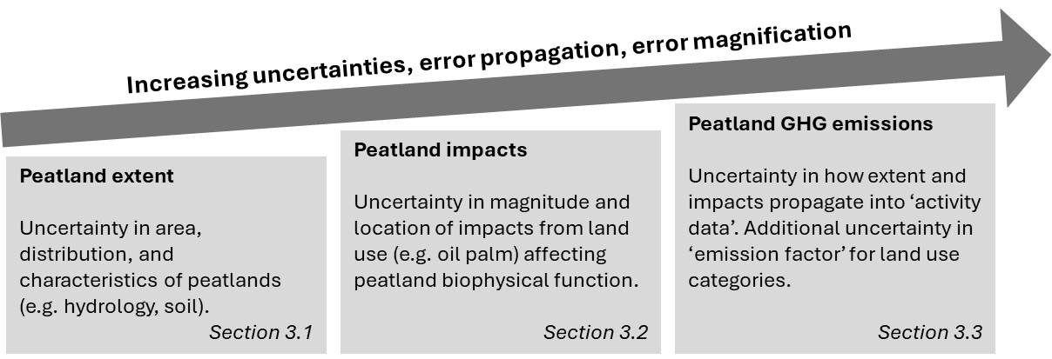
Figure 3: Flow chart diagram showing links between the illustrative analyses presented in this section, and different dimensions of uncertainty.

3.1 Uncertainties in peatland extent
Even when overall areal estimates are similar, the distribution of peatlands can vary greatly. For example, in Figure 4 we present a comparison between the datasets of Gumbricht et al. (2017), Xu et al. (2018), and UNEP (2022) (Table 2) which reveals a lack of consensus on the distribution of peatlands. For this visualisation we have included the UNEP (2022) dataset, which was excluded from earlier quantitative comparisons (Section 2.1) due to inconsistencies between the spatial datafile and statistics presented within the UNEP (2022) report. Spatial differences between datasets become more apparent when zooming into specific areas. Figure 4B shows that while these maps agree on the general areas of peatland, exact boundaries vary substantially among the data sources. Figure 4C further illustrates the influence of pixel size and data structures (i.e. raster or vector), which drive differences between datasets at finer scales. For example, raster data may include many small, isolated patches of peatland as pixels, whereas vector data generally preserve the geometry of the peatlands. In our mapped example (Figure 4), while the finer-scale data from Gumbricht et al. (2017), with a pixel size of 232 m, offers detailed mapping, the other two datasets have comparatively coarser resolutions (Table 2).

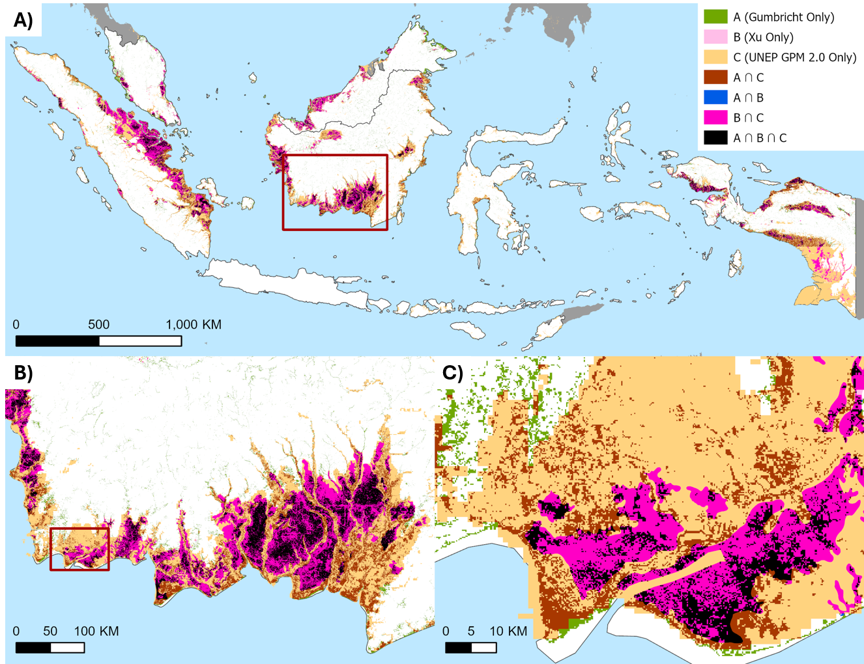

Figure 4: Mapping discrepancies in peatland distribution, with the intersection (∩) representing locations identified as peatland across one or more datasets. (A) Shows areas of agreement and disagreement between peatland datasets across all of Indonesia and Malaysia. (B) Provides a detailed view of a region in Kalimantan (red box in A), showing that different sources generally identify a peatland area, but the actual extent and precision of the mapping varies between datasets. (C) Provides a more detailed view of the region indicated by the red box B. Note there are few examples of A∩B.

Differences in peatland mapping arise through varying practices in defining peat, difficulties in measuring peatland systems accurately and comprehensively, differences in methodologies, the dynamic nature of peatland landscapes (Wahyunto and Suryadiputra, 2008; Lourenco et al., 2022), as well as misclassification of remote sensing data. For example, peat thickness plays a critical role in defining peat (see Table 2), assessing functions such as carbon storage, and for understanding peatland development and land-use management decisions (Parry et al., 2014; Minasny et al., 2019). Thus mapping disagreements reflect at least three distinct forms of uncertainty: semantic uncertainty over what counts as peat, measurement uncertainty in detecting peat extent and thickness, and representation uncertainty arising from scale, resolution, and data structure.

While the thickness of tropical peat varies significantly (Page et al., 2011a), mapping thickness is challenging. Ground-based methods like probing and ground-penetrating radar are resource-intensive. Conversely, remote sensing techniques struggle to measure peat depth due to subsurface variability and face challenges in tropical regions where extensive cloud cover frequently obstructs retrievals (Minasny et al., 2024; Fiantis et al., 2023; Parry et al., 2014). Several studies have mapped the spatial distribution of peat and its thickness in Indonesia and Malaysia (e.g. Anda et al., 2021; Gumbricht et al., 2017; Widyastuti et al., 2025). Anda et al. (2021) determined peat thickness in Indonesia using field measurements and satellite imagery, categorizing depth into six classes from “shallow” (50-100 cm) to “exceptionally very deep" (>700 cm). Gumbricht et al, (2017) used a model-based approach, incorporating biophysical indicators and terrain data to estimate peat depth and distribution across tropical regions, while Widyastuti et al. (2025) modelled both peat thickness and carbon stocks globally, within the peatland extent of UNEP (2022). Comparisons between peatland depth datasets in Indonesia would be informative, but are limited by availability of data (Table 2).

Peatland extent and depth are two key indicators of peatland quantity, and crucial for characterising its condition and contribution to carbon storage. Many other physical, spatial, and temporal properties of peatlands are equally or more challenging to assess. For example, peat bulk density and organic carbon content are critical indicators of peatland ecosystems, but cannot be directly mapped using remote sensing. Instead, mapping depends on proxies and correlations, due to obstructions from ground cover and tree canopy (UNEP, 2022). Thus, a key part of the methodological challenge in peatland mapping and quantification is the disciplinary diversity required, from remote sensing to soil science and chemistry. Overall, this section highlights how a range of sources of uncertainty, including varying depth-based definitions of peat and uncertainty in measuring and modelling peat thickness, contribute to uncertainty in peatland area and distribution (e.g. Figure 4).

3.2 Uncertainties in oil palm on peatland
While differences between peatland extent datasets can be substantial, the challenge is compounded by the need for multiple spatial datasets in many applications of peatland management. Combining multiple datasets can potentially compound uncertainty and propagate errors (Lechner et al. 2012). We use oil palm as a worked example because it is both a major driver of peatland conversion in the region (see Section 2.2) and a land-use category for which spatial data are widely used in certification, compliance, and sustainability reporting. As with peatland extent, there are numerous maps of oil palm extent, covering different time periods (Figures 5, S1, S2). Importantly given rapid land use changes, some datasets provide continuous records beginning in 1987, while most are available only for a single year, with greater coverage after 2015. While the various datasets indicate increasing oil palm coverage across Indonesia and Malaysia, detailed comparisons reveal large discrepancies in both areas and trends. Across eight datasets, estimates of total oil palm area vary by up to 70% (Figure 5A), with regional discrepancies exceeding a 2.5-fold difference between datasets (Figure 5). Part of this disagreement reflects genuine temporal mismatch among datasets as well as differences in classification methods and semantic definitions, reinforcing that estimates are sensitive to both spatial and temporal inconsistency. Some datasets explicitly acknowledge uncertainty, with Xu et al. (2020) reporting upper and lower bounds for oil palm area estimates, while Petersen et al. (2016) distinguishes between “oil palm only” and “oil palm mix” to capture semantic uncertainty.

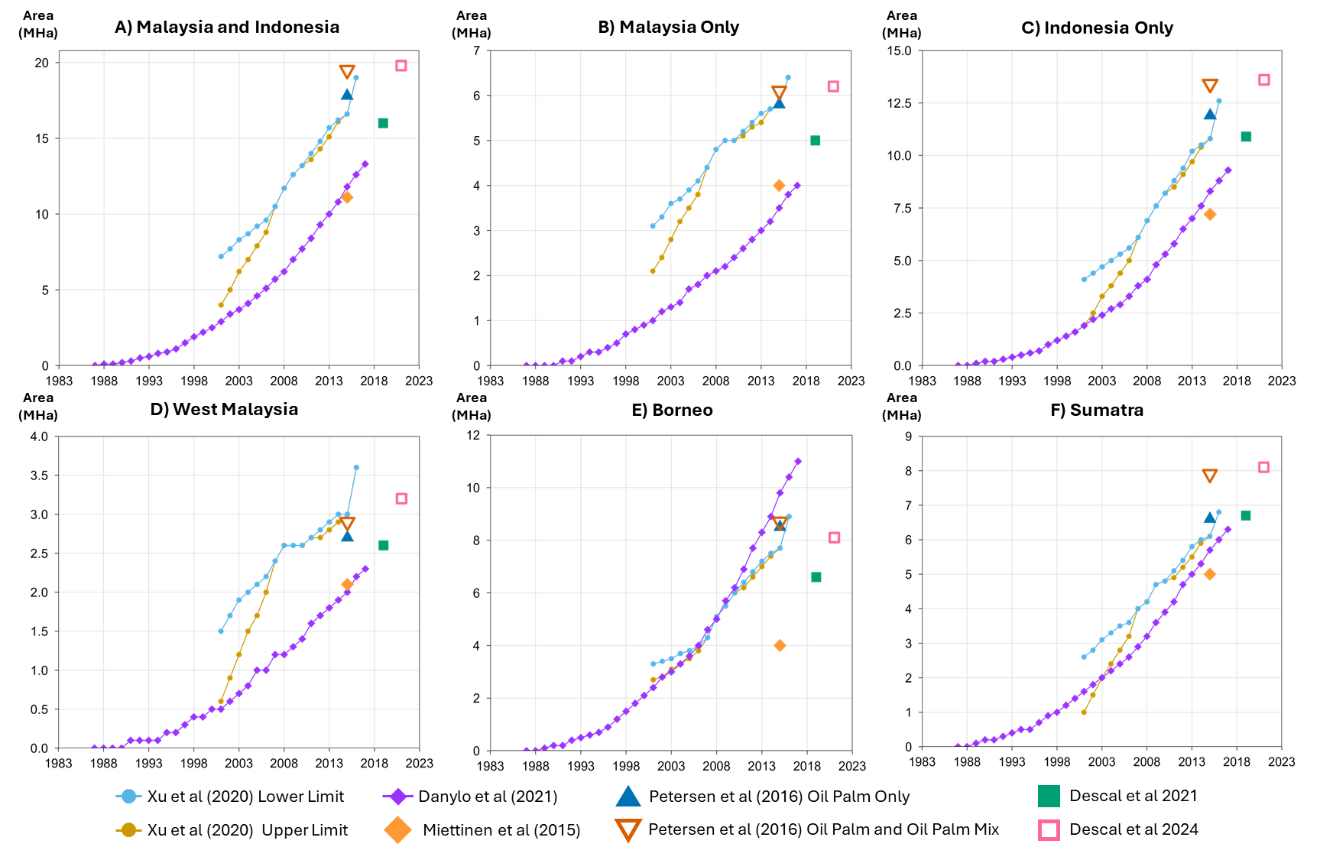
Figure 5: Time series of the oil palm datasets area (MHa) for A) Malaysia and Indonesia (Sumatra and Kalimantan), B) Malaysia only, C) Indonesia only, D) West Malaysia (Peninsular Malaysia), E) Borneo (Kalimantan and East Malaysia) and F) Sumatra, from 2000 to 2019. The data nodes are labelled with the source reference and publication dates.

Uncertainty magnifies when oil palm datasets are combined with peatland extent datasets, for example in answering the fundamental question: “how much oil palm is on peatland?”. Figure 6 shows four estimates of oil palm area within peatlands, from calculating the area of overlap between the four possible combinations of two oil palm datasets (Danylo et al., 2021; Descal et al., 2021) with two peatland datasets (Gumbricht et al., 2017; Xu et al., 2018). Because these estimates are calculated as total pixel counts from categorical map overlays, rather than from a statistical sampling design, uncertainty is represented here through dataset-combinations (i.e. rather than confidence intervals). Depending on the combination, total oil palm areas in peatlands of Indonesia and Malaysia combined range between 1.5–2.2 Mha. When considering the areas of overlap across all four datasets (i.e. a conservative estimate), the area calculated is just 0.4 Mha. In contrast, for a less conservative estimate, the intersection between merged oil palm datasets and merged peatland datasets is almost 3.8 Mha. These large discrepancies underscore how strongly results depend on dataset selection and treatment, and highlight the difficulty of meaningfully quantifying land-use disturbances.

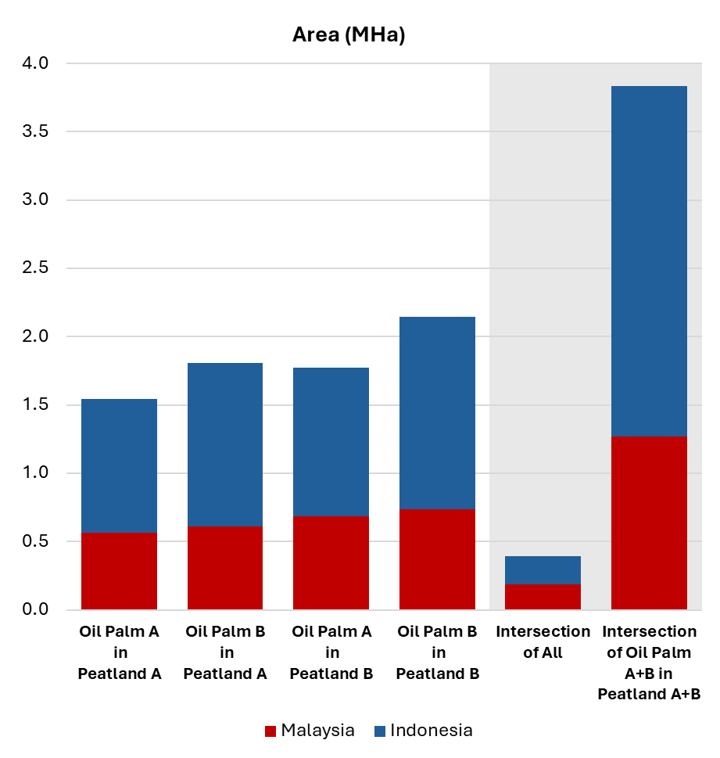
Figure 6: Areas of oil palm in peatland calculated by combining datasets. The first four bars compare the various combinations of two oil palm datasets (A) Danylo et al. (2021) and (B) Descal et al. (2021) with two peatland datasets (A) Gumbricht et al. (2017) and (B) Xu et al. (2018), for Malaysia against Indonesia. The fifth bar shows a conservative intersection of all four datasets, quantifying areas where peatland is present in both datasets and oil palm is present in both datasets. The sixth (rightmost) bar shows the intersection of all oil palm areas (union of oil palm A+B) within both peatland datasets (union of peatland A+B), reflecting a more generous coverage. These are total pixel-count areas derived from deterministic overlay of categorical map products, rather than modelled area estimates with associated confidence intervals. Note also that the datasets have different temporal reference periods. The peatlands dataset of Xu et al (2018) is a composite synthesis drawing on source data from multiple years and decades and Gumbricht et al. (2017) reflects peatland conditions around 2011. For Danylo et al. (2021) time-series oil palm dataset we used their most recent year, 2017 and Descal et al. (2021) represents 2019. While temporally inconsistent, these datasets are commonly used as the best available representations for current applications.

These analyses demonstrate how uncertainty is magnified when spatial datasets are combined, leading to error propagation. In practical terms, this means that a single plantation area could be classified differently depending on which peatland and land-use layers are selected, risking inconsistent results for certification, compliance checks, and project baselines. While illustrated here using oil palm and peatland layers, the same issue applies to other commonly overlaid datasets, including fire occurrence, drainage infrastructure, and forest loss (Figure 2). The adoption of good practice in mapping and area estimation, such as the approaches outlined by Tyukavina et al. (2025), including avoiding direct area estimation from classified maps and explicitly accounting for map error, is essential for producing statistically defensible results. These practices, alongside thorough documentation and transparent reporting, should be embedded within broader quality assurance frameworks to support downstream analyses and to make uncertainty propagation explicit rather than implicit. Uncertainty arising from combining peatland data with other datasets can undermine certification systems such as RSPO, carbon credit MRV systems, and has direct implications for GHG accounting, which is examined further in the next section. Taken together, uncertainty propagation constitutes a ubiquitous challenge for peatland management and governance.

3.3 Uncertainties in peatland greenhouse gas emission estimates
In this section we focus on comparing national-scale peatland GHG emission estimates, but note that sub-national (e.g. project scale) estimates are increasingly important. Discrepancies among peatland GHG emissions estimates arise from multiple sources, including differences in peat area assumptions, land-state classifications, emission factors, process and gas coverage, and the years represented. Estimates rely on various observational methods, including in situ chamber measurements of GHG fluxes, eddy covariance tower observations, upscaling approaches based on remote sensing by unmanned aerial vehicles (UAV) and satellites, and process-based biogeochemical modelling (e.g. Hoyt et al., 2020; Desmukh et al. 2023; Basri et al., 2024; Kasak et al., 2025), yet multiple challenges lead to uncertainties. Spatial heterogeneity in peatland vegetation, hydrology and land-use means uncertainty is introduced by extrapolating local emission measurements across large areas, or applying those data at unmeasured sites. Similarly, emissions fluctuate temporally, leading to uncertainties when relying on short-term measurements. There are also different carbon accounting practices (i.e. stock difference and gain-loss methods, ex-ante and ex-post estimates), and not all approaches include the full range of carbon fluxes and pools or all relevant GHGs, including methane and nitrous oxide (Murdiyarso et al., 2024).

These observational challenges and uncertainties propagate into emissions estimates, including national inventories (e.g. BTRs; Section 2.3) which are developed using Intergovernmental Panel on Climate Change guidelines (IPCC, 2006; 2013). In essence, emissions are calculated as the product of an emitting activity or activity data (e.g. an area under a particular land use) and an emission factor (an emission rate, per unit activity), both affected by uncertainties. Calculations can be conducted within varying tiers of detail and complexity. The simplest Tier 1 approach relies on default emission factors and basic activity data. Tier 2 employs country-specific emissions factors, typically informed by local peatland measurements. Tier 3 may involve more detailed models, spatial data, site-specific measurements, and long-term flux monitoring, potentially resulting in more accurate estimates but requiring substantial technical resources. Indonesia and Malaysia largely use Tier 1 approaches for estimating LULUCF emissions, but reflecting their importance, Indonesia has developed country-specific emission factors, based on multiple field observations (Novita et al., 2021), for a Tier 2 approach to peatland emissions that has also been applied in Indonesia’s second Forest Reference Level (Republic of Indonesia, 2022).

To illustrate the importance of assumptions and data uncertainties within calculations of GHG emissions, and to demonstrate the value of transparency in methodological documentation, we compare multiple estimates of peatland GHG emissions for Indonesia and Malaysia (Figure 7). We first compare UNEP (2022) and Miettinen et al. (2017) ([1] and [2] in Figure 7), demonstrating the importance of assumptions in peatland areas. Both estimate peat decomposition emissions only and deploy default IPCC (i.e. Tier 1) emission factors for non-pristine peatland areas. For Malaysia, total peatland area assumed is similar (2.5 and 2.7 Mha, respectively). While not all details of peatland state are available in UNEP (2022), the effective emission factors (that emerge from the emission calculation, weighted by the sizes of areas in different states) are also similar, and thus calculated emissions are similar (90 and 97 MtCO₂e). For Indonesia, the large difference in estimated emissions (668 and 440 MtCO₂e) likely arises due to the smaller peatland area assumed in Miettinen et al. (2017), which did not calculate emissions for all provinces.

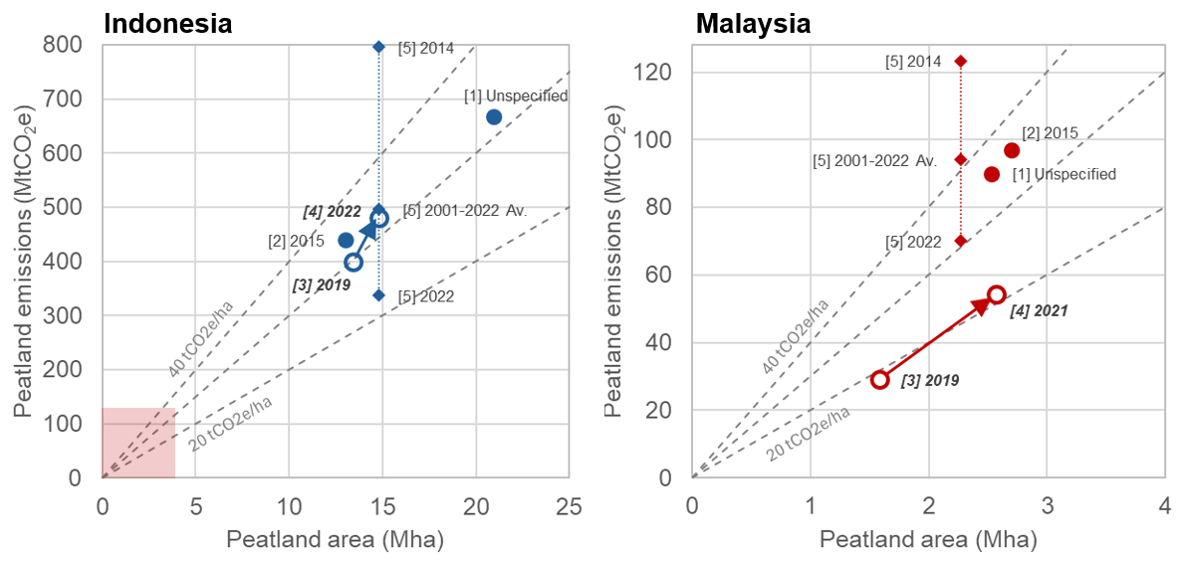
Figure 7: Estimates of peatland GHG emissions, plotted as a function of the peatland area reported in the study, in Indonesia (left) and Malaysia (right). The red shading in the lower corner of the Indonesia plot indicates the emission-area space in the Malaysia plot. The year for which the estimate is made is indicated. The sources of the estimates are: [1] UNEP (2022); [2] Miettinen et al. (2017); [3] Latest national BURs; [4] Latest national BTRs; [5] Sasmito et al. (2025). National reports are shown with open circles, with arrows showing updates from most recent BURs (Republic of Indonesia, 2021; Government of Malaysia, 2022) to BTRs. The final effective emission factor for a study, and thus the positioning of the marker relative to the dashed grey diagonal lines, will reflect the proportion of peatland areas in differing state categories (e.g. oil palm) and the specific emission factor used for each category. Emissions are presented using common units of tCO₂e, though some estimates only consider CO₂ emissions.

Emissions reported by both countries to the UNFCCC, in BTRs and in preceding Biennial Update Reports (BURs), are also shown in Figure 7 (arrows show the change from BUR to BTR, for emissions in the latest reported year). In Malaysia’s BTR the reported emission (54 MtCO₂) is larger than in its preceding (fourth) BUR (29 MtCO₂). This difference appears to be predominantly due to the larger area of organic soil in the cropland category in the BTR (1.8 Mha, out of the total reported 2.6 Mha of organic soil) than in the fourth BUR (1.1 Mha of a total 1.6 Mha). The implied emission factor in both the fourth BUR and the BTR is similar, close to 20 tCO₂e/ha. For Indonesia, we focus this comparison between the most recent (third) BUR and BTR on peatland decomposition (i.e. loss of organic soil), and ignore separately reported emissions from peatland fires. While changes in reporting approach hinder detailed comparison, both a modest increase in total peatland area, and a slightly higher implied emission factor, lead to higher emissions in the BTR (479 MtCO₂e) than the preceding third BUR (398 MtCO₂e). For both countries, this comparison involves different reporting years, which may also contribute to differences in reported emissions.

The standardised data tables associated with BTRs also enable comparisons of the methodological approaches taken by different countries. The reporting includes areas of organic soil in specified land categories, alongside “implied carbon stock change factors” (equivalent to emission factors if carbon is lost to the atmosphere as CO₂). The reported factors for organic soils in croplands are -7.53 and -11.53 tC/ha for Malaysia and Indonesia, respectively, equivalent to emission factors of 27.6 and 42.3 tCO₂/ha. There are similar differences for other land categories, with the factors for organic soils in forest land also greater in Indonesia’s report. These inter-country differences in choice of emission factor are a major cause of the differing relative positions of the markers labelled [4] in Figure 7.

Using peatland areas from Xu et al. (2018), Sasmito et al. (2025) provided more detailed emissions estimates, considering variations by year and additional emitting processes. The connected diamonds labelled [5] in Figure 7 show the effect of selecting different years to estimate emissions, comparing the average of 22 years with two specific years: 2014 (highest emissions) and 2022 (lowest emissions). Earlier years had larger contributions from peatland drainage, deforestation and fire (in sum 71% and 59% of 2014 emissions, in Indonesia and Malaysia respectively). By 2022, these emitting processes are less important, leaving peat decomposition as the major (close to 80%) contributor in both countries, and resulting in lower estimates of total emissions. The dataset of Sasmito et al. (2025) therefore highlights the importance of temporal fluctuations in anthropogenic activities in peatlands, and in contributions from multiple emitting processes. Similarly, the work of Sasmito et al. (2025) supports the case for separately reporting emissions contributions from individual GHGs linked to specific processes. This approach is also relevant to assessing potential peatland interventions, such as rewetting of drained peatlands aiming to reduce peat oxidation and CO₂ emissions, while potentially increasing CH₄ emissions under some conditions (Evans et al., 2021; Sasmito et al., 2025).

Overall, our comparisons show the value of reporting transparency in understanding how uncertain data inputs contribute to differences between calculated GHG emissions. For Malaysia’s national reporting, while the peatland (organic soil) area used in the BTR is broadly consistent with other studies, the use of a lower implied emission factor results in lower reported emissions. For Indonesia, the estimates of area and emissions from decomposition in the BTR, and in Miettinen et al. (2017) and Sasmito et al. (2025), are broadly similar. The UNEP (2022) estimate is affected by a much larger assumed peatland area. The areas considered here have been aggregated nationally, and will thus influence reported contributions to national and global carbon emissions. Further enhancements in Tier 2 and 3 approaches and in transparent methodological documentation would further strengthen credibility. However, in sub-national areas (e.g. relevant to projects generating carbon credits), uncertainties and locational disagreement in peatland extent and status (Sections 3.1, 3.2) could propagate into even larger uncertainties in emissions. For this reason, improving transparency in both activity data and emission factors is crucial for credible peatland accounting at national and project scales.

4. Conclusion: Cross-cutting challenges and opportunities for peatland data to support sustainability interventions

With pervasive uncertainties in mapping and quantification, this review emphasises that uncertainty in peatland data is central to peatland management and governance. Because peatland extent, condition, land use, and emissions data underpin certification, MRV, national inventories, and conservation planning, their limitations directly shape the credibility and effectiveness of sustainability interventions. Achieving desired sustainability outcomes will require enhancing the accessibility and accuracy of peatland datasets, and managing uncertainty in data transparently across spatial and institutional scales. Table 4 synthesizes the seven key data challenges identified in this review, outlining associated uncertainties, consequences, and actionable recommendations. These challenges converge around three cross-cutting opportunities: (1) enhance data practices across borders and scales, (2) engage constructively with data uncertainty, and (3) value broader sustainability benefits.

Table 4: Seven key peatland challenges, identified from the workshop, are presented alongside their importance and data needs, associated uncertainties and consequences, and recommendations for improving peatland data and sustainability policies in Indonesia and Malaysia. These recommendations are underpinned by three cross-cutting opportunities: (1) enhance data practices across scales and borders, (2) constructively engage with data uncertainty, and (3) value broader sustainability benefits, which are cited in the rightmost column.
Key Data Challenge | Importance of Peatlands and Data Needs | Peatland Data Uncertainties and Consequences | Recommendations for Peatland Data and Sustainability Policy
1. Peatland Extent | Mapping peatland boundaries and hydrological and ecological units needed to identify and prioritize areas for management and interventions. | Disagreements on definitions, varying mapping methods, and limited coverage in space and time of field data. Leading to fundamental uncertainties in characterisation of peatland extent and distribution hindering assessments of GHG emissions and conservation. | Improved spatial data availability, with transparent methodologies and quantification of uncertainty, are needed to address extent mismatches, as these affect error propagation and all peatland quantification and management efforts (1,2)
2. Peat Soil Characteristics and Hydrology | Essential for understanding peatland health in terms of soil characteristics (e.g. depth and bulk density), water management (e.g. canals), fire susceptibility, and flood risks. | Lack of data on peat soil and hydrology, with limited field measurements in space and time (e.g., water depth). Leads to uncertainty in characterisation of peatland conditions, particularly problematic for restoration initiatives. | Accurate data on peat soil and hydrology are critical inputs for all aspects of peatland quantification (e.g. GHG emissions), and effective management. Extensive fieldwork required as well as further developments of novel remote sensing methods (1,2).
3. Biodiversity | Supports biodiversity conservation, ecosystem health assessments. | Lack of detailed, accurate mapping of peatland biodiversity and ecosystem health, with limited data on many species, especially non-mammals and birds. Hinders effective conservation planning, overlooking critical habitats, contributing to local species declines and potential extinctions. | Parallel assessments of carbon stock and flora diversity, and greater research on link between peatland condition and biodiversity loss (or conservation). (1,3)
4. Greenhouse Gas Emissions | Quantify emissions, support climate change mitigation efforts, and evaluate carbon storage capacity, particularly important for reporting to UNFCCC and for carbon credit projects. | Limited spatially-explicit belowground carbon stock data; high variability of GHG emissions in space and time; limited data on methane and nitrous oxide emissions; high uncertainty in emission factors for decomposition, fire and rewetting; lack of adequate baseline data for carbon projects. Lowers confidence in peatland's role in GHG emissions and reduction targets, and leads to carbon credit integrity risks. | Transparent and detailed reporting of peatland emission methodologies can clarify contribution to national or corporate targets and support data harmonization at the regional scale. Approaches that foreground uncertainty are likely to reduce risks to integrity of outcomes. (1, 2)
5. Land Use, Management and Community Engagement | Identification of drivers of degradation such as agriculture, and of key stakeholders (i.e. local communities, involved companies) to inform and support protection and restoration efforts. Evaluation of management effectiveness. | Missing spatial data on restored peatlands; lack of accessible site-level data; outdated land-use change data. Mismatches in administrative/jurisdictional boundaries and biophysical boundaries and lack of clear land tenure can result in policies that do not support the natural hydrology of peatlands. | Engaging local communities in peatland data collection, management, and translation can foster ownership, advocacy, and culturally appropriate, accessible information. Potential to contribute to data-driven, context-specific interventions, sustainable stewardship, and informed policy influence. (1,2,3)
6. Spatial Data Quality, Transparency and Open Data | Systematic and transparent assessment of spatial data quality supports fitness-for-use evaluations and understanding of error propagation, while open data enables broader stakeholder access, use, and contribution to peatland information. | Lack of systematic assessment and transparency in spatial data quality and uncertainty, leads to error propagation and hinders management. Lack of available “official” spatial data and/or limited open data access results in stakeholders using a variety of inconsistent and non-standard datasets. | Formal recognition of uncertainty through spatial data quality metrics, transparent metadata, and modelling methods for assessing fitness-for-use and error propagation, enabling advanced modelling of uncertainty, alongside open data, are essential for robust and consistent analysis. (1,2)
7. Policy and Regulatory Needs | Evidence-based, data-driven approaches guide effective conservation and restoration strategies, promote equitable management, and embed transparency and spatial data quality into decision-making processes. | Policies that ignore data uncertainty and lack evidence-based approaches risk leading to poor and potentially biased and/or harmful decisions. | Integrate quantitative approaches and uncertainty assessment into decision-making processes, grounded in the precautionary principle. (1,2,3)

Several of our recommendations emphasise a need for improved peatland data. The proliferation of sensors and platforms including optical, radar and time-series satellite data, together with high-resolution UAV-derived data (Lechner et al., 2020), combined with field observations, digital soil mapping and machine-learning methods, provide new opportunities to map peatlands more widely, accurately and consistently (Minasny et al., 2019). Such observations are providing new fundamental knowledge of the extent of tropical peatlands (e.g. Crezee et al., 2022; Winton et al., 2025) and can characterise peatlands more precisely by capturing detailed temporal variability and spatial heterogeneity. Additional observations may also reveal further processes relevant to peatland sustainability, such as methane emissions from drainage ditches in converted peatlands (e.g. Kasak et al., 2025). However, uncertainty will not be eliminated by improved and additional data. Instead, uncertainty connected to the complexity of peatland ecosystems, such as genuine spatial heterogeneity, temporal variability and incomplete understanding of peatland processes will continue to be relevant. In contrast, as we argue, uncertainty connected to data practices, such as inconsistent definitions, limited provision of metadata, and poor harmonisation across borders, can be both reduced and more transparently characterised. Overall, uncertainty will remain an evolving property of complex peatland socio-economic systems, even while new and improved data are collected, highlighting a need for more explicit appreciation of data uncertainty, and for consideration of acceptable levels of certainty for specific governance purposes (e.g. Kovács et al., 2026).

A productive approach to addressing the identified data challenges would incorporate the three highlighted cross-cutting opportunities. As one example, for Challenge 5, we recommend engaging local communities in peatland data collection, management, and translation to enhance data practices (Opportunity 1). Community-led data verification exercises can provide a trusted, on-the-ground audit of management practices and their impacts, yielding culturally appropriate information and context-specific policy interventions (Varkkey et al., forthcoming) (Opportunity 2). Ultimately, such processes can incorporate multiple metrics alongside qualitative indicators to fully value broader sustainability benefits (Opportunity 3), ensuring that land management decisions support not just carbon outcomes but also community livelihoods, cultural values, and biodiversity, thereby fostering stewardship and resilience. Experiences in Indonesia with community fire management and peatland restoration in Ogan Komering Ilir district, South Sumatra and Pulang Pisau district, Central Kalimantan show communities can be effectively engaged to address peatland data issues. In this case, community contributions were essential in developing Indonesia’s Peat Fire Danger Rating System (Robins et al, 2022). Exploratory surveys among peat communities in Perak and Selangor, Malaysia furthermore revealed 74% of community members wanted to contribute to peat conservation through participation in community-based management (Nath et al., 2016).

Similarly, to support peatland policy and regulation (Challenge 7), we recommend embedding quantitative approaches and uncertainty assessment into decision-making. Grounded in the precautionary principle, and incorporating all three cross-cutting opportunities identified, this ensures data limitations are addressed conservatively. Systemic, data-driven approaches have potential to guide effective peatland conservation and restoration across scales and borders (Opportunity 1). For protected areas, this means that uncertainty should be considered explicitly in conservation gap analyses, protected area expansion, and restoration prioritisation, rather than assuming that existing peatland maps provide fixed estimates of protection status. At the regional scale, ASEAN’s Peatland Management Strategy 2023–2030 (APMS; ASEAN Secretariat, 2023) emphasises enhancing spatial data to support effective management (Varkkey et al., 2024). Nevertheless, the APMS does not explicitly provide a framework for quantifying, reporting and managing the major data uncertainties reviewed here. Such uncertainties (e.g. over hotspots indicating fires, often within peatlands) have hindered regional cooperation over transboundary “haze” pollution. Evaluation of the various datasets relevant to peatlands now available could be overseen by an ASEAN panel of experts (e.g. Murulitharan & Ashfold, 2021). This panel, or an equivalent authority, could provide consensus statements on the quality, consistency and fitness-for-use of datasets, assess the potential influence of uncertainty and error propagation on decision-making, and support harmonisation of datasets and MRV systems across borders (Opportunity 2). Such approaches are also called for through ASEAN’s Roadmap on Transboundary Haze Pollution Control (ASEAN Secretariat, 2024), underscoring the potential co-benefits that can be achieved through improved data approaches for peatland policy and regulations (Opportunity 3).

Overall, this review has provided a comprehensive assessment of persistent data challenges and uncertainties constraining peatland management and governance. By integrating insights from an expert workshop with spatial analyses, and a structured approach designed to quantify and visualize key uncertainties, our interdisciplinary synthesis has characterized seven critical data challenges and demonstrated how uncertainties can propagate into downstream policy approaches. Our recommendations contribute to progressing from uncertain and heterogeneous peatland datasets into actionable evidence for peatland research and policy in Malaysia and Indonesia, and in peat landscapes worldwide. Issues we have highlighted, such as inconsistent definitions, dataset disagreement, error propagation and governance under uncertainty are widely relevant, including in the Congo Basin, Amazonia and Europe. At the same time, issues such as land-use pressures, peat characteristics, emission factors, mapping capacity and regulatory settings may differ quite substantially between regions. Thus, rather than waiting for perfect data, peatland governance should proceed treating data uncertainty explicitly and transparently, with decisions and safeguards designed for persistent uncertainty. This will support the continued integration of peatlands into global climate and sustainability strategies, ensuring these critical ecosystems are governed through robust decision-making frameworks designed for real-world complexity.

Acknowledgments
We thank all those who have contributed to the development of this review for their time, knowledge and support. This includes those who participated directly in the expert workshop for this paper, and those who contributed to the wider project that helped to frame the review, including peatland community members who participated in focus groups in Selangor, Malaysia and Pontianak, Indonesia, and government, civil society, and corporate stakeholders who were interviewed in Indonesia, Malaysia and Singapore. We thank Mr Shiva Prasad for his work in designing Figure 1 in this paper.

Author Contributions
MJA, HV, GZA, SS, NW, FTA and AML designed and organized the expert workshop that informed the development of this manuscript. MJA, HV, GZA, NW, FTA, ZDT, ML, NN, HLT, DS, BA, MKS, SAP, AY and AML contributed to the expert workshop and subsequent documentation of discussions. MJA, NW, MLEA and AML performed geospatial mapping and quantitative analyses. MJA, HV and AML designed the broad direction of the manuscript and initiated a first draft. MJA, HV, NW, FTA, ZDT and AML conducted reviews and wrote subsections. GZA, SS, MLEA, ML, NN, GMF, HLT and DS conducted reviews and provided comments on the manuscript. MJA, HV and ALM finalized the draft. MJA, NW, FTA and ALM organized co-author consultations and management for drafting. All authors read and approved of the final manuscript.

Financial Support
This paper is an output of grant IF070-2022, "Policy and governance approaches to cooperative mitigation of peatland carbon emissions and transboundary haze in Southeast Asia" (CRRP2022-03MY-Muhamad Varkkey), supported by the Asia Pacific Network on Global Change Research Collaborative Regional Research Programme. ZDT is supported by the Climate Transformation Program, a Tier 3 Academic Research Fund from the Singapore Ministry of Education (MOE-MOET32022-0006).

Conflicts of Interest Declarations
The authors declare no conflicts of interest.

Data Availability
This paper uses publicly available datasets which are cited in-text and included in the reference list. Links to the spatial datasets used are also available at the project’s website:
https://seapeat.wixsite.com/home/open-data

References
Adrianto, H. A., Spracklen, D. V., & Arnold, S. R. (2019). Relationship between fire and forest cover loss in Riau Province, Indonesia between 2001 and 2012. Forests, 10(10), 889. https://doi.org/10.3390/f10100889.
Anda, M., Dariah, A., Wulandari, D., Sulaeman, Y., & Subiksa, I. G. M. (2021). Revisiting tropical peatlands in Indonesia: Semi-detailed mapping, extent and depth distribution assessment. Geoderma, 402, 115235. https://doi.org/10.1016/j.geoderma.2021.115235.
ASEAN Secretariat (2023). ASEAN Peatland Management Strategy 2023-2030. Jakarta. https://asean.org/wp-content/uploads/2024/04/APMS-2-Apr-Web.pdf
ASEAN Secretariat (2024). The Second Roadmap for ASEAN Cooperation on Transboundary Haze Pollution Control with Means of Implementation. Jakarta. https://asean.org/wp-content/uploads/2024/09/The-Second-Haze-Free-Roadmap-2023-2030.pdf
Azhar, B., Lindenmayer, D. B., Wood, J., Fischer, J., Manning, A., McElhinny, C., Zakaria, & M. 2011). The conservation value of oil palm plantation estates, smallholdings and logged peat swamp forest for birds. Forest Ecology and Management, 262(12), 2306-2315. https://doi.org/10.1016/j.foreco.2011.08.026.
Basri, M. H. A., McCalmont, J., Kho, L. K., Hartley, I. P., Teh, Y. A., Rumpang, E., Signori-Müller, C., & Hill, T. (2024). Reducing bias on soil surface CO2 flux emission measurements: Case study on a mature oil palm (Elaeis guineensis) plantation on tropical peatland in Southeast Asia. Agricultural and Forest Meteorology, 350, 110002. https://doi.org/10.1016/j.agrformet.2024.110002.
Cao, P., Bilotto, F., Gonzalez Fischer, C. et al. (2026). Spatially explicit global assessment of cropland greenhouse gas emissions circa 2020. Nat. Clim. Chang. https://doi.org/10.1038/s41558-026-02558-4.
Castle, S. E., Newton, P., Oldekop, J. A., Baylis, K., & Miller, D. C. (2025). Global forest dataset incongruence creates high uncertainties for conservation, climate, and development policy. One Earth, 101558. https://doi.org/10.1016/j.oneear.2025.101558 ‌
Climate Catalyst. (2023). Business guide to peatlands. https://climatecatalyst.org/wp-content/uploads/2024/05/Business-Guide-to-Peatlands-Climate-Catalyst.pdf
Crezee, B., Dargie, G. C., Ewango, C. E. N., Mitchard, E. T. A., Emba B., O., Kanyama T., J., Bola, P., Ndjango, J.-B. N., Girkin, N. T., Bocko, Y. E., Ifo, S. A., Hubau, W., Seidensticker, D., Batumike, R., Imani, G., Cuní-Sanchez, A., Kiahtipes, C. A., Lebamba, J., Wotzka, H.-P., … Lewis, S. L. (2022). Mapping peat thickness and carbon stocks of the central Congo Basin using field data. Nature Geoscience, 15(8), 639–644. https://doi.org/10.1038/s41561-022-00966-7
Dadap, N. C., Hoyt, A. M., Cobb, A. R., Oner, D., Kozinski, M., Fua, P. V., & Konings, A. G. (2021). Drainage canals in Southeast Asian peatlands increase carbon emissions. AGU Advances, 2(1), e2020AV000321. https://doi.org/10.1029/2020AV000321.
Danylo, O., Pirker, J., Lemoine, G., & others. (2021). A map of the extent and year of detection of oil palm plantations in Indonesia, Malaysia and Thailand. Scientific Data, 8, 96. https://doi.org/10.1038/s41597-021-00867-1.
Department of Agriculture Malaysia. (2002). Reconnaissance soil map of Peninsular Malaysia [Map] (Scale 1:750,000).
Department of Irrigation and Drainage Sarawak. (2014). Distribution of peat soils in Sarawak. http://www.did.sarawak.gov.my/modules/web/page.php?id=97&menu_id=0&sub_id=117.
Descals, A., Wich, S., Meijaard, E., Gaveau, D. L. A., & Peedell, S. (2021). High-resolution global map of smallholder and industrial closed-canopy oil palm plantations. Earth System Science Data, 13, 1211–1231. https://doi.org/10.5194/essd-13-1211-2021.
Descals, A., Gaveau, D. L. A., Wich, S., Szantoi, Z., & Meijaard, E. (2024). Global mapping of oil palm planting year from 1990 to 2021. Earth System Science Data, 16, 5111–5129. https://doi.org/10.5194/essd-16-5111-2024.
Deshmukh, C. S., Susanto, A. P., Nardi, N. et al. (2023). Net greenhouse gas balance of fibre wood plantation on peat in Indonesia. Nature 616, 740–746. https://doi.org/10.1038/s41586-023-05860-9.
Devillers, R., & Jeansoulin, R. (2006). Spatial Data Quality: Concepts. In R. Devillers & R. Jeansoulin (Eds), Fundamentals of Spatial Data Quality (1st edn, pp. 31–42). Wiley. https://doi.org/10.1002/9780470612156.ch2
Devillers, R., Stein, A., Bédard, Y., Chrisman, N., Fisher, P., & Shi, W. (2010). Thirty years of research on spatial data quality: Achievements, failures, and opportunities. Transactions in GIS, 14(4), 387–400. https://doi.org/10.1111/j.1467-9671.2010.01212.x.
European Parliament (2023). Regulation (EU) 2023/1115 of the European Parliament and of the Council of 31 May 2023. https://www.google.com/url?q=https://environment.ec.europa.eu/topics/forests/deforestation/regulation-deforestation-free-products_en&sa=D&source=docs&ust=1770972462037438&usg=AOvVaw2TKEDvP-iq3pqhu4JLfHjW
Evans, C. D., Peacock, M., Baird, A. J., Artz, R. R. E., Burden, A., Callaghan, N., Chapman, P. J., Cooper, H. M., Coyle, M., Craig, E., Cumming, A., Dixon, S., Gauci, V., Grayson, R. P., Helfter, C., Heppell, C. M., Holden, J., Jones, D. L., Kaduk, J., … Morrison, R. (2021). Overriding water table control on managed peatland greenhouse gas emissions. Nature, 593. https://doi.org/10.1038/s41586-021-03523-1
Fiantis, D., Rudiyanto, Gusnidar, Ginting, F. I., Padrikal, R., Prayoga, D., & Nelson, M. (2023). Carbon and phosphorus in volcanic soils of Mt. Kerinci (Sumatra) after long-term tea and paddy cultivation. Communications in Soil Science and Plant Analysis, 54(22), 3169–3184. https://doi.org/10.1080/00103624.2023.2253843.
Fisher, P., Comber, A., & Wadsworth, R. (2006). Approaches to Uncertainty in Spatial Data. In Fundamentals of Spatial Data Quality (pp. 43–59). Wiley. https://doi.org/10.1002/9780470612156.ch3
Gaveau, D. L. A., Salim, M. A., Hergoualc’h, K., Locatelli, B., Sloan, S., Wooster, M., Marlier, M. E., Molidena, E., Yaen, H., DeFries, R., Verchot, L., Murdiyarso, D., Nasi, R., Holmgren, P., & Sheil, D. (2014). Major atmospheric emissions from peat fires in Southeast Asia during non-drought years: evidence from the 2013 Sumatran fires. Scientific Reports, 4(1). https://doi.org/10.1038/srep06112 ‌
Goldstein, Jenny E. 2022. “More Data, More Problems? Incompatible Uncertainty in Indonesia’s Climate Change Mitigation Projects”. Geoforum 132 (June): 195–204. https://doi.org/10.1016/j.Geoforum.2021.11.007
Goodchild, M. (2008). Imprecision and Spatial Uncertainty. In: Shekhar, S., Xiong, H. (eds) Encyclopedia of GIS. Springer, Boston, MA. https://doi.org/10.1007/978-0-387-35973-1_592
Government of Malaysia. (2022). Biennial Update Report (BTR4). https://unfccc.int/documents/624776.
Government of Malaysia. (2024). Biennial Transparency Report (BTR1). https://unfccc.int/documents/645171.
Grover, S., Treby, S., Mendham, D. S., & Rawluk, A. (2024). Social and ecological dimensions of tropical peatland restoration. Mires and Peat. https://doi.org/10.19189/MaP.2023.OMB.Sc.2114019.
Gumbricht, T., Roman-Cuesta, R. M., Verchot, L., Herold, M., Wittmann, F., Householder, E., Herold, N., & Murdiyarso, D. (2017). An expert system model for mapping tropical wetlands and peatlands reveals South America as the largest contributor. Global Change Biology, 23(9), 3581–3599. https://doi.org/10.1111/gcb.13689.
Hansen, M. C., Potapov, P. V., Moore, R., Hancher, M., Turubanova, S. A., Tyukavina, A., Thau, D., Stehman, S. V., Goetz, S. J., Loveland, T. R., Kommareddy, A., Egorov, A., Chini, L., Justice, C. O., & Townshend, J. R. G. (2013). High-resolution global maps of 21st-century forest cover change. Science, 342(6160), 850–853. https://doi.org/10.1126/science.1244693.
Harris, N. L., Gibbs, D. A., Baccini, A., Birdsey, R. A., de Bruin, S., Farina, M., Fatoyinbo, T., Hansen, M. C., Herold, M., Houghton, R. A., Potapov, P. V., Suarez, D. R., Roman-Cuesta, R. M., Saatchi, S. S., Slay, C. M., Turubanova, S. A., & Tyukavina, A. (2021). Global maps of twenty-first century forest carbon fluxes. Nature Climate Change, 11, 234–240. https://doi.org/10.1038/s41558-020-00976-6.
Heuvelink, G. B. M., Burrough, P. A., & Stein, A. (1989). Propagation of errors in spatial modelling with GIS. International Journal of Geographical Information Systems, 3(4), 303–322. https://doi.org/10.1080/02693798908941518
Hoyt, A. M., Chaussard, E., Seppalainen, S. S., Harvey, C. F., Cobb, A. R., & Konings, A. G. (2020). Widespread subsidence and carbon emissions across Southeast Asian peatlands. Nature Geoscience, 13, 435–440. https://doi.org/10.1038/s41561-020-0575-4.
Huijnen, V., Wooster, M., Kaiser, J., Gaveau, D. L. A., Flemming, J., Parrington, M., Inness, A., Murdiyarso, D., Main, B., & van Weele, M. (2016). Fire carbon emissions over maritime Southeast Asia in 2015 largest since 1997. Scientific Reports, 6, 26886. https://doi.org/10.1038/srep26886.
Intergovernmental Panel on Climate Change. (2006). 2006 IPCC guidelines for national greenhouse gas inventories. IPCC-TFI/NGGIP. https://www.ipcc-nggip.iges.or.jp/public/2006gl/.
Intergovernmental Panel on Climate Change (Hiraishi, T., Krug, T., Tanabe, K., Srivastava, N., Baasansuren, J., Fukuda, M., & Troxler, T. G., Eds.). (2014). 2013 supplement to the 2006 IPCC guidelines for national greenhouse gas inventories: Wetlands. IPCC-TFI/NGGIP. https://www.ipcc-nggip.iges.or.jp/public/wetlands/.
International Union for Conservation of Nature. (2023). IUCN 2023 annual report. Access at: https://iucn.org/resources/annual-reports/iucn-2023-international-union-conservation-nature-annual-report.
Kasak, K., Dronova, I., Soosaar, K., Melling, L., Xhuan, W. G., Sangok, F., Ranniku, R., Villa, J. A., Bansal, S., Peacock, M., & Mander, Ü. (2025). Greenhouse gas emissions from ditches in oil palm plantations on tropical peatlands in Malaysia. Scientific Reports, 15(1). https://doi.org/10.1038/s41598-025-21094-3
Kovács, G. M., Tong, X., Gominski, D., Oehmcke, S., Horion, S., Abel, C., Ivits, E., Schurgers, G., Elberling, B., Prishchepov, A., van der Linden, S., Page, S., Barthelmes, A., Tanneberger, F., & Fensholt, R. (2026). Highly fragmented European wetlands with uneven restoration needs. Nature, 655, 932–941. https://doi.org/10.1038/s41586-026-10760-9
Lechner, A. M., Foody, G. M., & Boyd, D. S. (2020). Applications in Remote Sensing to Forest Ecology and Management. One Earth, 2(5), 405–412. https://doi.org/10.1016/j.oneear.2020.05.001
Lechner, A. M., Langford, W. T., Bekessy, S. A., & Jones, S. D. (2012). Are Landscape Ecologists Addressing Uncertainty in Their Remote Sensing Data? Landscape Ecology, 27, 1249–1261. https://doi.org/10.1007/s10980-012-9791-7
Lee, J. S. H., Jaafar, Z., Tan, A. K. J., Carrasco, L. R., Ewing, J. J., Bickford, D. P., Webb, E. L., & Koh, L. P. (2016). Toward clearer skies: Challenges in regulating transboundary haze in Southeast Asia. Environmental Science & Policy, 55, 87–95. https://doi.org/10.1016/j.envsci.2015.09.008 ‌
Lestari, N. S., Rochmayanto, Y., Salminah, M., Novita, N., Asyhari, A., Gangga, A., Ritonga, R., Yeo, S. and Albar, I. (2024). Opportunities and risk management of peat restoration in Indonesia: lessons learned from peat restoration actors. Restor Ecol, 32: e14054. https://doi.org/10.1111/rec.14054
Lourenco, M., Fitchett, J. M., & Woodborne, S. (2022). Peat definitions: A critical review. Progress in Physical Geography: Earth and Environment, 47(4), 506-520. https://doi.org/10.1177/03091333221118353.
Melling, L. (2016). Peatland in Malaysia. In M. Osaki & N. Tsuji (Eds.), Tropical peatland ecosystems (pp. 59–74). Springer. https://doi.org/10.1007/978-4-431-55681-7_4
Melton, J. R., Chan, E., Millard, K., Fortier, M., Winton, R. S., Martín-López, J. M., Cadillo-Quiroz, H., Kidd, D., & Verchot, L. V. (2022). A map of global peatland extent created using machine learning (Peat-ML), Geosci. Model Dev., 15, 4709–4738. https://doi.org/10.5194/gmd-15-4709-2022.
Miettinen, J., Shi, C., & Liew, S. C. (2016). 2015 land cover map of Southeast Asia at 250 m spatial resolution. Remote Sensing Letters, 7(7), 701–710. https://doi.org/10.1080/2150704X.2016.1182659.
Miettinen, J., Hooijer, A., Vernimmen, R., Liew, S. C., & Page, S. E. (2017). From carbon sink to carbon source: extensive peat oxidation in insular Southeast Asia since 1990. Environmental Research Letters, 12, 024014, 1–10. https://doi.org/10.1088/1748-9326/aa5b6f.
Minasny, B., Adetsu, D. V., Aitkenhead, M., & others. (2024). Mapping and monitoring peatland conditions from global to field scale. Biogeochemistry, 167, 383–425. https://doi.org/10.1007/s10533-023-01084-1.
Mishra, S., Page, S. E., Cobb, A. R., Lee, J. S. H., Jovani‐Sancho, A. J., Sjögersten, S., Jaya, A., Aswandi, & Wardle, D. A. (2021). Degradation of Southeast Asian tropical peatlands and integrated strategies for their better management and restoration. Journal of Applied Ecology, 58(8), 1746–1762. https://doi.org/10.1111/1365-2664.13905.
Murdiyarso, D., Swails, E., Hergoualc’h, K., Bhomia, R., & Sasmito, S. D. (2024). Refining greenhouse gas emission factors for Indonesian peatlands and mangroves to meet ambitious climate targets. Proceedings of the National Academy of Sciences of the United States of America, 121(17), e2307219121. https://doi.org/10.1073/pnas.2307219121.
Murulitharan, J. & Ashfold, M. J. (2021). Depoliticising Southeast Asia’s forest fire pollution. East Asia Forum. https://eastasiaforum.org/2021/08/17/depoliticising-southeast-asias-forest-fire-pollution/
Mutalib, A. A., Lim, J. S., Wong, M. H., & Koonvai, I. (1991, March 8–10). Characterization, distribution and utilization of peat in Malaysia. Symposium on Tropical Peat Land, Kuching, Sarawak.
Nath, T. K., Dahalan, M. P. B., Parish, F., & others. (2017). Local peoples’ appreciation on and contribution to conservation of peatland swamp forests: Experience from Peninsular Malaysia. Wetlands, 37, 1067–1077. https://doi.org/10.1007/s13157-017-0941-1.
Novita, N., Lestari, N. S., Lugina, M., Tiryana, T., Basuki, I., & Jupesta, J. (2021). Geographic setting and groundwater table control carbon emission from Indonesian peatland: A meta-analysis. Forests, 12(7), 832. https://doi.org/10.3390/f12070832.
Novita, N., Lestari, N. S., Anshari, G. Z., Lugina, M., Yeo, S., Malik, A., & Ellis, P. (2022). Natural climate solutions in Indonesia: Wetlands are the key to achieve Indonesia’s national climate commitment. Environmental Research Letters, 17(11), 114045. https://doi.org/10.1088/1748-9326/ac9e0a.
Padfield, R., Drew, S., Syayuti, K., Page, S., Evers, S., Campos-Arceiz, A., Kangayatkarasu, N., Sayok, A., Hansen, S., Schouten, G., Maulidia, M., Papargyropoulou, E. & Mun Hou Tham (2016) Landscapes in transition: an analysis of sustainable policy initiatives and emerging corporate commitments in the palm oil industry, Landscape Research, 41:7, 744-756. https://doi.org/10.1080/01426397.2016.1173660.
Page, S. E., Rieley, J. O., & Banks, C. J. (2011a). Global and regional importance of the tropical peatland carbon pool. Global Change Biology, 17(2), 798–818. https://doi.org/10.1111/j.1365-2486.2010.02279.x.
Page, S. E., Morrison, R., Malins, C., Hooijer, A., Rieley, J. O. & Jauhiainen, J. (2011b). Review Of Peat Surface Greenhouse Gas Emissions From Oil Palm Plantations In Southeast Asia. www.theicct.org.
Parry, L. E., Holden, J., & Chapman, P. J. (2014). Restoration of blanket peatlands. Journal of Environmental Management, 133, 193–205. https://doi.org/10.1016/j.jenvman.2013.11.033.
Petersen, R., & others. (2016). Mapping tree plantations with multispectral imagery: Preliminary results for seven tropical countries (Technical Note). World Resources Institute. https://www.wri.org/publication/mapping-treeplantations.
Reed, M. S., Young, D. M., Taylor, N. G., Andersen, R., Bell, N. G. A., Cadillo-Quiroz, H., Grainger, M., Heinemeyer, A., Hergoualc’h, K., Gerrand, A. M., Kieft, J., Krisnawati, H., Lilleskov, E. A., Lopez-Gonzalez, G., Melling, L., Rudman, H., Sjogersten, S., Walker, J. S., & Stewart, G. (2022). Peatland Core Domain Sets: Building Consensus on What Should Be Measured in Research and Monitoring. Mires and Peat, 28, 26. https://doi.org/​10.19189/​MaP.2021.OMB.StA.2340.
Republic of Indonesia. (2021). Biennial Update Report (BUR3). https://unfccc.int/documents/403577
Republic of Indonesia. (2022). National forest reference level for deforestation, forest degradation and enhancement of forest carbon stock in the context of decision 12/CP.17 para 12 UNFCCC. Jakarta, Indonesia.
Republic of Indonesia. (2024). Biennial Transparency Report (BTR1). https://unfccc.int/documents/645082
Robins, L., van Kerkhoff, L., Rochmayanto, Y., & others. (2022). Knowledge systems approaches for enhancing project impacts in complex settings: Community fire management and peatland restoration in Indonesia. Regional Environmental Change, 22, 100. https://doi.org/10.1007/s10113-022-01960-w.
RSPO (2019). Factsheet on Peat Requirements for RSPO Growers. Roundtable on Sustainable Palm Oil. https://rspo.org/wp-content/uploads/peat-factsheet-eng.pdf
Sasidhran, S., Adila, N., Hamdan, M. S., Samantha, L. D., Aziz, N., Kamarudin, N., Puan, C. L., Turner, E., & Azhar, B. (2016). Habitat occupancy patterns and activity rate of native mammals in tropical fragmented peat swamp reserves in Peninsular Malaysia. Forest Ecology and Management, 363, 140-148. https://doi.org/10.1016/j.foreco.2015.12.037.
Sasmito, S. D., Taillardat, P., Adinugroho, W. C., & others. (2025). Half of land use carbon emissions in Southeast Asia can be mitigated through peat swamp forest and mangrove conservation and restoration. Nature Communications, 16, 740. https://doi.org/10.1038/s41467-025-55892-0.
Shuhada, S. N., Sabiha, S., Nobilly, F., Zubaid, A., & Azhar, B. (2017). Logged peat swamp forest supports greater macrofungal biodiversity than large‐scale oil palm plantations and smallholdings. Ecology and Evolution, 7(18), 7187-7200. https://doi.org/10.1002/ece3.3273.
Soto-Navarro, C., Ravilious, C., Arnell, A., de Lamo, X., Harfoot, M., Hill, S.L.L., Wearn, O.R., Santoro, M., Bouvet, A., Mermoz, S., Le Toan, T., Xia, J., Liu, S., Yuan, W., Spawn, S.A., Gibbs, H.K., Ferrier, S., Harwood, T., Alkemade, R. and Schipper, A.M. (2020). Mapping co-benefits for carbon storage and biodiversity to inform conservation policy and action. Philosophical Transactions of the Royal Society B: Biological Sciences, 375(1794), p.20190128. https://doi.org/10.1098/rstb.2019.0128.
Struebig, M. J., Lee, J. S. H., Deere, N. J., & others. (2025). Drivers and solutions to Southeast Asia’s biodiversity crisis. Nature Reviews Biodiversity, 1, 497–514. https://doi.org/10.1038/s44358-025-00064-7.
Tanneberger, F., & Belous, T. (2017). The peatland map of Europe. Mires and Peat, 19, 1–17. https://doi.org/10.19189/MaP.2016.OMB.264.
Teo, H.C., Tan, N.H.L., Zheng, Q. et al. (2023). Uncertainties in deforestation emission baseline methodologies and implications for carbon markets. Nat Commun 14, 8277. https://doi.org/10.1038/s41467-023-44127-9.
Terzano, D., Trezza, F. R., Rezende, M., Malatesta, L., Yan, S. L. S., Parish, F., & Attorre, F. (2023). Prioritization of peatland restoration and conservation interventions in Sumatra, Kalimantan and Papua. Journal for Nature Conservation, 73, 126388. https://doi.org/10.1016/j.jnc.2023.126388.
Tyukavina, A., Potapov, P., Hansen, M. C., Pickens, A. H., Stehman, S. V., Turubanova, S., Parker, D., Zalles, V., Lima, A., Kommareddy, I., Song, X.-P., Wang, L., & Harris, N. (2022). Global trends of forest loss due to fire from 2001 to 2019. Frontiers in Remote Sensing, 3, 825190. https://doi.org/10.3389/frsen.2022.825190.
Tyukavina, A., Stehman, S. V., Pickens, A. H., Potapov, P., & Hansen, M. C. (2025). Practical global sampling methods for estimating area and map accuracy of land cover and change. Remote Sensing of Environment, 324, 114714. https://doi.org/10.1016/j.rse.2025.114714
UNEP. (2022). Global peatlands assessment: The state of the world’s peatlands – Evidence for action toward the conservation, restoration, and sustainable management of peatlands. United Nations Environment Programme. https://doi.org/10.59117/20.500.11822/41222.
Varkkey, H., Ashfold, M., Anshari, G., & Lechner, A. M. (2024). Mitigating carbon emissions and haze in Southeast Asia’s peatlands: Opportunities and challenges in integrating policy and governance. ISEAS–Yusof Ishak Institute. https://www.iseas.edu.sg/articles-commentaries/trends-in-southeast-asia/mitigating-carbon-emissions-and-haze-in-southeast-asias-peatlands/.
Varkkey, H., Ashfold, M. J., Anshari, G. Z., Lechner, A. M., Seah, S., Alkaf, F. T., & Wijayanti, N. (forthcoming). Participatory Methods to Inform Policy and Governance in Southeat Asia’s Peatlands, in D. Miteva (Ed.), Research Handbook for Ecosystem Services. Edward Elgar Publishing.
Wahyunto, S. I., & Suryadiputra, I. N. N. (2008). Peatland distribution in Sumatra and Kalimantan: Explanation of its data sets including source of information, data constraints, and gaps. Wetlands International–Indonesia Programme.
Wahyunto, Suparto, B., Heryanto, B., & Bekti, H. (2006). Sebaran lahan gambut, luas dan cadangan C bawah permukaan di Papua (Peatland distribution, area extent, and C stock of peat in Papua). Wetlands International–Indonesia Programme.
Wahyunto, R. S., & Suparto, S. H. (2004). Maps of area of peatland distribution and carbon content in Kalimantan, 2000–2002. Wetlands International–Indonesia Programme and Wildlife Habitat Canada.
Wahyunto, S., Ritung, S., Suparto, & Subagjo, H. (2003). Map of peatland distribution and its C content in Sumatera. Wetlands International–Indonesia Programme and Wildlife Habitat Canada.
Widyastuti, M.T., Minasny, B., Padarian, J., Maggi, F., Aitkenhead, M., Beucher, A., Connolly, J., Fiantis, D., Kidd, D., Ma, Y., Macfarlane, F., Robb, C., Setiawan, B.I. and Taufik, M. (2025). Digital mapping of peat thickness and carbon stock of global peatlands. Catena, 258, 109243. https://doi.org/10.1016/j.catena.2025.109243
Winton, R. S., Benavides, J., Mendoza, E., Uhde, A., Hastie, A., Coronado, E. H., Giovanny, A., Paukku, S., Mullins, B., Aguila, Aymard, G. A., Baker, T., Draper, F., Llampazo, G. F., Herrera, R., Phillips, O. L., José Reyna Huaymacari, Steege, H., Stropp, J., … Hoyt, A. M. (2025). Widespread carbon-dense peatlands in the Colombian lowlands. Environmental Research Letters. https://doi.org/10.1088/1748-9326/adbc03
Xu, J., Morris, P. J., Liu, J., & Holden, J. (2018). PEATMAP: Refining estimates of global peatland distribution based on a meta-analysis. Catena, 160, 134–140. https://doi.org/10.1016/j.catena.2017.09.010.
Xu, Y., et al. (2020). Annual oil palm plantation maps in Malaysia and Indonesia from 2001 to 2016. Earth System Science Data, 12, 847–867. https://doi.org/10.5194/essd-12-847-2020.
Yule, C. M. (2010). Loss of biodiversity and ecosystem functioning in Indo-Malayan peat swamp forests. Biodiversity and Conservation, 19(2), 393–409. https://doi.org/10.1007/s10531-008-9510-5.

Supplementary materials

Methodological approaches to the review

Expert workshop
Our hybrid workshop involved participants from Indonesia, Malaysia, and Singapore. Participants were identified through the professional networks of the academics leading the project through which the workshop was organised. The workshop was conducted on 7 August 2024 at Monash University Indonesia, and brought together 22 peatland experts. 16 participants joined in person and 6 joined online. Across the participants, 14 were from Indonesian institutions, 6 from Malaysian institutions, and 2 from Singaporean institutions. From an alternative perspective, 8 participants were environmental practitioners (i.e. from NGOs or consulting organisations), 8 were from academic institutions, and 6 from governmental bodies.

Prior to the workshop we identified four themes: 1) Peatland Data needs, 2) Mapping peatland and its condition, 3) Calculating GHG emissions from peatlands, and 4) Cross-cutting challenges and opportunities for enhancing peatland data to support sustainability interventions (presented in Table 1). For each of the four themes we held group discussions both online and in small breakout tables, focusing on questions relevant to Indonesia and Malaysia. Discussion points from the workshop were compiled in an Excel spreadsheet, and participants were subsequently invited to submit further written reflections and supporting evidence. A smaller working group then consolidated and refined these contributions. As part of the consolidation exercise, an artificial intelligence (AI) tool (Microsoft Copilot) was used to summarise the workshop notes contained in an anonymised version of the Excel spreadsheet and to generate initial outlines for Figure 1 and for Table 4. The AI outputs were cross-checked against the workshop notes, and were refined over multiple iterations by the authors to create the final versions.

GIS methods
Overlay analyses were conducted for area and percentage calculations. Datasets were first converted from their original raster formats to vector representations and projected to a Cylindrical Equal Area coordinate system to ensure accurate area estimation. The analyses did not aim to derive absolute values but to illustrate the overall magnitude of differences between datasets. All spatial analyses were conducted in ArcGIS Pro 3.6.1 (ESRI, 2023).

Esri. 2023. ArcGIS Pro. Version 3.6.1. Environmental Systems Research Institute, Redlands, CA.

Table S1: Statistical summary of mapped quantities in Figure 2, by country and region.
Region / Country | Peatland extent (1,000 km²) |  |  |  | Forest Loss in Peatland  (1,000 km²) |  | Oil Palm in Peatland (1,000 km²) |  |  |  | Protected Peatland  (1,000 km²) |  | Forest Emission (MtCO₂e y⁻¹) |  |  | Forest Removal (MtCO₂e y⁻¹)
Region / Country | Xu et al | Gumbricht et al | Agreement Area | Extent | All driver | by Fire | Industrial | Small-  holder | Total |  |  |  | Total | in Peatland |  | Total | in Peatland
Sumatra | 64.0 | 59.9 | 25.9 | 97.6 | 41.8 | 5.7 | 9.6 | 6.3 | 15.9 | (16%) | 6.6 | 7% | 444 | 201 | 45% | 213 | 67 | 31%
Kalimantan | 49.2 | 64.7 | 23.2 | 90.7 | 24.9 | 7.6 | 5.2 | 0.8 | 6.0 | (7%) | 12.8 | 14% | 385 | 112 | 29% | 188 | 40 | 21%
Papua | 36.4 | 72.3 | 18.9 | 89.8 | 1.6 | 0.2 | 0.2 | 0.0 | 0.2 | (0%) | 16.9 | 19% | 36 | 6.5 | 18% | 85 | 36 | 43%
Sulawesi | - | 7.8 | - | 7.8 | 0.8 | 0.1 | 0.1 | 0.2 | 0.3 | (4%) | 0.4 | 6% | 66 | 2.6 | 4% | 49 | 4 | 9%
Maluku | - | 2.5 | - | 2.5 | 0.1 | 0.0 | - | - | - | (0%) | 0.2 | 6% | 18 | 0.6 | 3% | 27 | 3 | 12%
Jawa Bali | - | 5.8 | - | 5.8 | 0.0 | 0.0 | 0.0 | 0.0 | 0.0 | (0%) | - | 0% | 8.1 | 0.1 | 1% | 39 | 1 | 3%
Nusa Tenggara | - | 0.3 | - | 0.3 | 0.0 | 0.0 | - | - | - | (0%) | 0.0 | 3% | 5.2 | 0.01 | 0% | 12 | 0 | 1%
Indonesia | 149.6 | 213.3 | 68.0 | 294.8 | 69.3 | 13.6 | 15.0 | 7.4 | 22.4 | (8%) | 36.4 | 13% | 961 | 322 | 34% | 612 | 152 | 25%
West Malaysia | 7.5 | 11.3 | 2.9 | 15.8 | 5.0 | 0.2 | 2.3 | 0.8 | 3.1 | (20%) | 0.3 | 2% | 84 | 12 | 14% | 42 | 6 | 15%
East Malaysia | 15.8 | 17.2 | 5.4 | 27.6 | 10.9 | 0.4 | 5.9 | 0.4 | 6.3 | (23%) | 1.9 | 7% | 151 | 45 | 30% | 63 | 12 | 20%
Malaysia | 23.3 | 28.4 | 8.3 | 43.4 | 15.9 | 0.7 | 8.2 | 1.2 | 9.4 | (22%) | 2.2 | 5% | 234 | 57 | 24% | 105 | 19 | 18%

Table S2. Descriptions of the illustrative datasets for anthropogenic activities and impacts relevant to peatlands used in creating maps in Figure 2.
Variable | Temporal resolution | Spatial resolution | Details of datasets and processing methods | Source
Forest loss | 2001 - 2024 | 30 meters | Forest loss indicates the removal or mortality of forest cover due to factors including mechanical harvesting, fire, disease, or storm damage. Forest cover is defined as vegetation greater than 5 meters in height. | Hansen et al. (2013)
Canal density | 2017 | N/A | Informed by satellite images from 2017. | Dadap et al. (2021)
Forest loss due to fire | 2001 - 2024 | 30 meters | Mapped within the extent of Hansen et al. (2013), is updated through to 2024, and includes fire-related forest losses due to both natural causes and human activity. We used only forest loss by fire with higher certainty (labelled “code 4” in this dataset). | Tyukavina et al (2022)
Oil palm plantation | 2019 | 10 meters | Smallholder and industrial plantation categories | Descals et al. (2021)
GHG emissions due to forest loss | 2001 - 2024 | 30 meters | Mapped within the extent of Hansen et al. (2013), and updated through to 2024. We used the forest emissions data, and did not include carbon removals due to forest gain. | Harris et al. (2021)
Protected areas | Compilation | Compilation | Global dataset of protected areas, both marine and terrestrial, and both national and international. Overlapping areas merged.. | IUCN and UNEP-WCMC, 2024

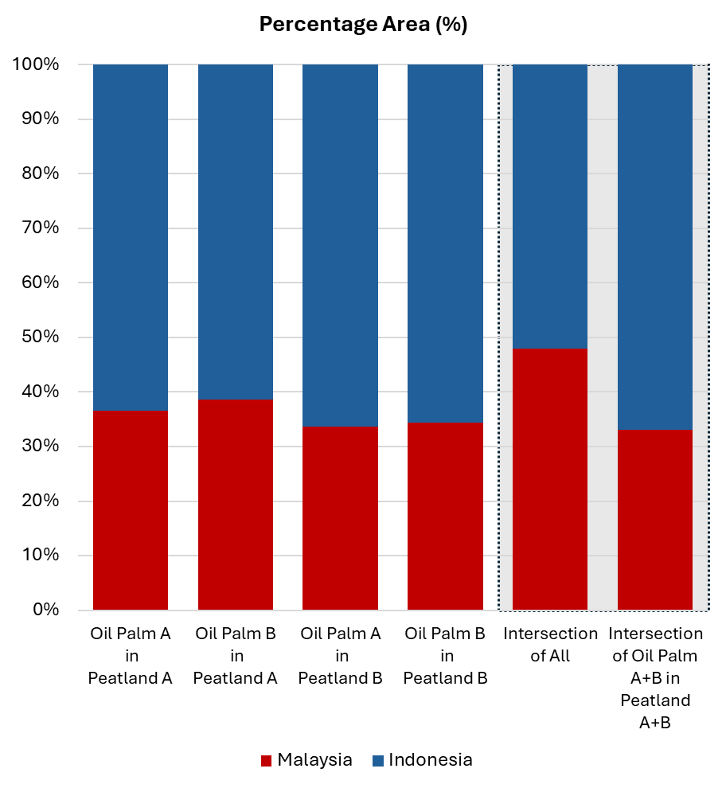
Figure S1: Areas of oil palm in peatland calculated by combining datasets, as described in Figure 6, but presenting the proportional split of oil palm in peatland between Malaysia and Indonesia when various dataset combinations are employed.

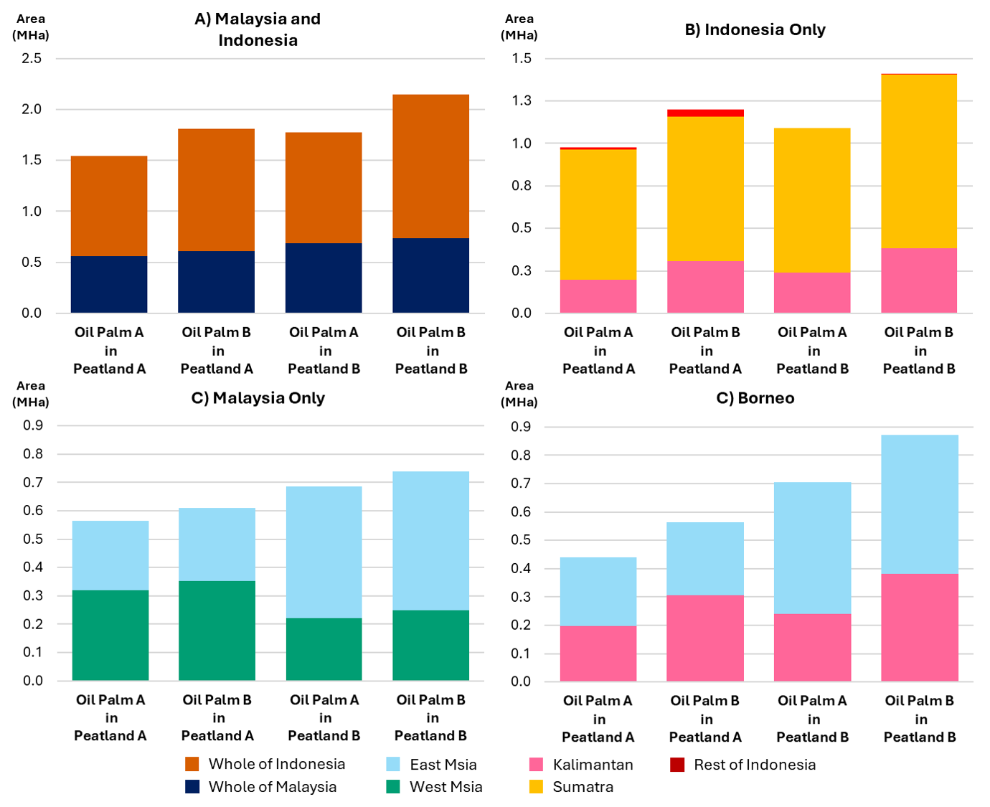
Figure S2: As in Figure 6, areas of oil palm in peatland calculated by various combinations of two oil palm datasets (A) Danylo et al. (2021) and (B) Descal et al. (2021) with two peatland datasets (A) Gumbricht et al. (2017) and (B) Xu et al. (2018), for different sub-regions of Malaysia and Indonesia. These differences in sub-regional areas further illustrate spatial discrepancies in both oil palm and peatland datasets.

